***Whispers of the American West: Desert Rain God***

**Level 18: 2010.255**

**Design Document**



Written by: Theresa Devine

Version: *03.00*

Date: *04/04/2021*



Copyright 2018-2021 *Studio 4 Game Innovation*. All Rights Reserved.

Do not Duplicate or Distribute without the express permission of the copyright holder.

This document is considered to be CONFIDENTIAL and PRIVATE.

# TABLE OF CONTENTS

TABLE OF CONTENTS 2

VERSION HISTORY 4

01.00.00 4

02.00.00 4

02.01.00 4

03.00.00 4

INTRODUCTION 5

CONCEPTUAL DEVELOPMENT 5

WHISPERS OF THE AMERICAN WEST: WORLD DIAGRAM 6

RELATED DOCUMENTS 7

OVERVIEW OF LEVEL DESIGN (DESERT RAIN GOD) (In Progress) 7

LEVEL DESIGN DIAGRAM 8

PUZZLE AND MISSION DESIGN LIST (IN PROGRESS) 12

ACCESSIBILITY & USE 13

INCLUSION 13

USER CHARACTERISTICS 13

USER OBJECTIVES 14

GAME REQUIREMENTS 14

USE CASE DIAGRAM (TO DO) 16

USE CASE NARRATIVE (TO DO) 16

STORY ARCHITECTURE (TO DO) 16

STORY STRUCTURE 16

STORY TYPE 16

STORY THROUGHLINES 16

SCRIPT MANAGEMENT 17

VISUAL ARCHITECTURE 17

AESTHETICS (TO DO) 17

COLOR THEORY (TO DO) 17

TYPOGRAPHY (TO DO) 17

VISUAL CHARACTER DESIGN (Little Rain God) (TO DO) 18

BUTTON MAP 19

USER INTERFACE (TO DO) 19

NAVIGATION HIERARCHY*.* 20

Screen [1.0]: Player Start 20

Screen [1.1]: Player explores the North Wing 20

Screen [1.2]: Player approaches painting 20

Screen [2.0]: Player Start in the Desert Rain God Level 21

Screen [2.1]: Player explores the level. 21

Screen [2.2]: Player finds the abandoned mine. 22

ENVIRONMENT DESIGN 22

Actual Claim 28 Site Photos 23

General Mine Photos – Navajo Nation 26

General Mine Photos – Utah 29

Mechanical Device Reference Image 31

SONIC ARCHITECTURE 31

SOUND EFFECTS: STINGERS 31

SOUND EFFECTS: TAGS 31

MUSIC: INTRO (TO DO) 31

MUSIC: LOOP (TO DO) 32

MUSIC: TRANSITION (TO DO) 32

GAMEPLAY DESIGN AND SOFTWARE ARCHITECTURE 32

LOGICAL VIEW (TO DO) 33

DATA VIEW (TO DO) 33

LOCALIZATION (TO DO) 33

INSTRUMENTATION VIEW (TO DO) 34

SECURITY VIEW (TO DO) 34

BIBLIOGRAPHY 34

# VERSION HISTORY

*About version numbers:*

*XX.YY.ZZ format*

*XX – major revisions, new sections, complete section revisions*

*YY – revisions to existing sections, major and minor*

*ZZ – small corrections, typos, grammar, formatting, etc.*

## 01.00.00

Written by Alvin Thai, Maedsyn Matthews, Ian McGonigle, Rinaldo Del Gallo (IAP 220: Introduction to Game Studies, Fall 2020)

*Added*: Initial Documentation

*Software Gameplay Architecture, Sonic Architecture, Visual Architecture, Accessibility and Use, Introduction*

## 02.00.00

Written by Theresa Devine and Richard Griffin (02/24/2021: NCUIRE Grant Spring 2020)

Added Conceptual Development section and researched concept and gameplay.

* Outcomes:
  + Environment design to be based on Abandoned Uranium Mines on the Navajo Nation Reservation
  + Gameplay mechanic – perspective altering puzzles
  + Conceptual basis – the Treaty of 1868 is still in effect and was what made it legal to mine on Navajo land. Article Article IX, section 6 gives the US permission.

## 02.01.00

Written by Theresa Devine and Richard Griffin (03/22/2021: NCUIRE Grant Spring 2020)

Updated:

* Title page, Introduction, Conceptual Development, World Diagram, Overview of Level (unfinished), Level Design Diagram, User Characteristics, User Objectives, Environment Design, and Sonic Architecture. Moved brainstorming for gameplay to Software Gameplay Architecture from the Conceptual Development section. Added a sketch for the main mechanic in the game.

Added:

* Melissa Bridges design to the World Diagram (IAP 220: Introduction to Game Studies, Fall 2018)
* Added Goals and Challenges to the Alignment Grid in the Overview
* Added Game Requirements 18-22

## 03.00.00

Written by Theresa Devine (04-05-2021)

Updated:

* Overview of Level Design, worked out some more of the mechanics on how to move the sun
* Goals and Challenges to the Alignment Grid, filled out entire grid. Have a couple of loose ends.
* Sonic Architecture, added in Yitazba Largo-Anderson’s role in the sound and how the students will work with her to create the sound in the game.

Added:

* Story Architecture
* Bibliography

# INTRODUCTION

The painter of *Desert Rain God*, Louisa McElwain, was fascinated by the way light changes when a storm comes in the American Southwest. (Phoenix Art Museum, 2010) The location of the painting appears to be in New Mexico, approximately somewhere on the Navajo Nation land. As Louisa McElwain studied the landscape and the light to create this painting, she was unaware of the political, social, and cultural significance of this land. This painting is an example of historical amnesia.

(Zolbrod, 1987)

In designing this level of the game, we answer the call of Nikki Sanchez, a Pipil/Maya and Irish/Scottish academic, Indigenous media maker and environmental educator (Keynote Speakers Canada, 2019) to face this historical amnesia. We aim to learn: 1) What treaties are important and why? 2) What system of oppression is still alive today because of that broken treaty? 3) What action can be taken today? (Sanchez, 2019)

This historical trauma is all of ours, and in this level of the game, we aim to teach the answers to these questions towards building a better tomorrow and encourage a renewed discussion about the issues of uranium mining, pollution, and reversing the damage on the land of the Diné. (Dooley, Umayam, & Luis, 2019)

## CONCEPTUAL DEVELOPMENT

|  |
| --- |
| Information provided by Phoenix Art Museum Education Dept.  About the art: 54 × 72 in. (137.2 × 182.9 cm)  Museum purchase with funds provided by Betty Van Denburgh in honor of Western Art Associates. (Bluemoon Fundraiser, 2021) (Phoenix Art Museum, 2018)  What the docents are currently teaching about the piece.   * In 19th century, women were not part of the great enthusiasm for landscape painting, but in the twentieth and twenty-first century women reclaimed it * The artist worked outside, *en plein air*, directly in contact with the landscape of Northern New Mexico * Bold, expressive style: she worked with palette knives and masonry trowels |

In the location that the painting was created, the Naal Tsoos Saní (The Old Paper): The Navajo Treaty of 1868 is the treaty is still in effect today. It has not yet been fully honored. (Harjo, 2014)

Article IX, section 6 of the Treaty states:

“They will not in future oppose the construction of railroads, wagon roads, mail stations, or **other works of utility or necessity** which may be ordered or permitted by the laws of the United States; but should such roads or other works be constructed on the lands of their reservation, the government, **will pay the tribe whatever amount of damage** may be assessed by three disinterested commissioners to be appointed by the President for that purpose, one of said commissioners to be a chief or head man of the tribe.”

(Unitah Basin Teaching American History, 2006)

It is this provision that allowed the US from 1944 to 1986, to extract nearly 30 million tons of uranium ore from Navajo lands under leases with the Navajo Nation. The abandoned mines are the source uranium contamination. This contagion has affected the water, homes, health, and future of the Diné. While there is an effort to clean up the pollution, the work of the US has been inadequate to date. (12 News Arizona, 2020) (US EPA, 2014)

The work of Navajo storyteller Sunny Dooley (Dooley, 2021) and nuclear nonproliferation expert and founder of Bombshelltoe Lovely Umayam influence this project. “*Ways of Knowing* is a creative attempt to bridge policy and humanity in examining the United States’ nuclear weapons production legacy … [and] serves as a reminder that nuclear weapons are not just made of secrecy, science, and steel; their power is in part derived from a naturally occurring element extracted from the Earth at the expense of Indigenous lives.” (Dooley, Umayam, & Luis, 2019) (Umayam, 2013)

The gameplay design will be influenced by *Hozho: Dine’ Concept of Balance and Beauty.* “Living in, or as sa’ah naaghaii bik’eh hozho means continually restoring, finding, and practicing balance in one’s daily life. The ability to live in balance is gained primarily through acquisition of knowledge. It is the possession of knowledge that makes one ‘divine,’ by virtue of putting one in closer contact with and able to better utilize the basic energetic forces underlying nature (Farella, 1093:24). The knowledge is acquired through ritual, stories, songs and experience in life, including all the good and bad of life.” (Unknown, 2012) (Farella, 1990) (Zolbrod, 1987)

## WHISPERS OF THE AMERICAN WEST: WORLD DIAGRAM

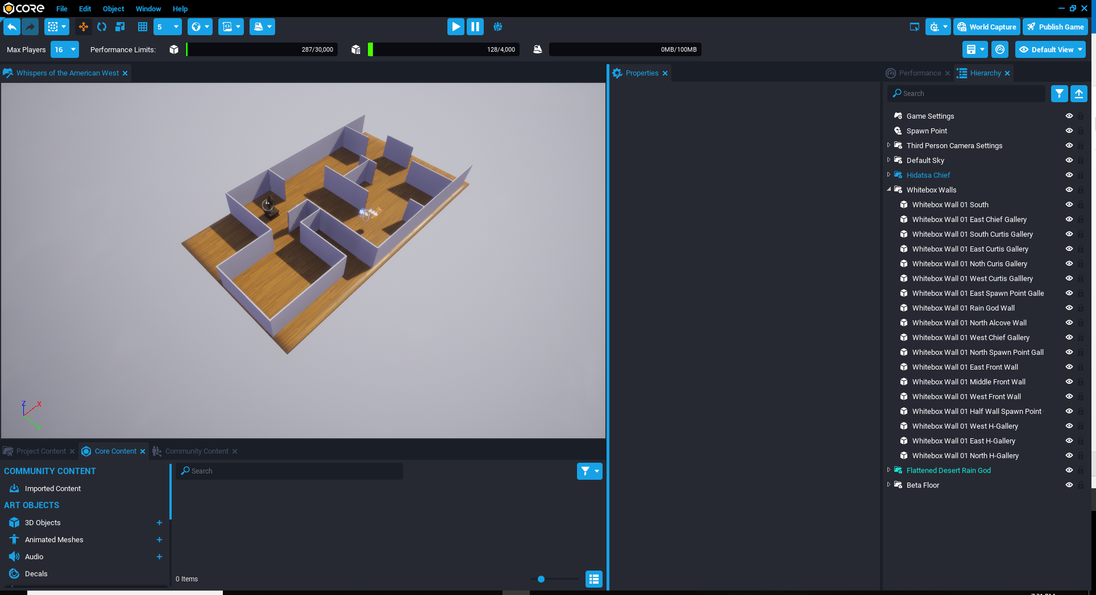

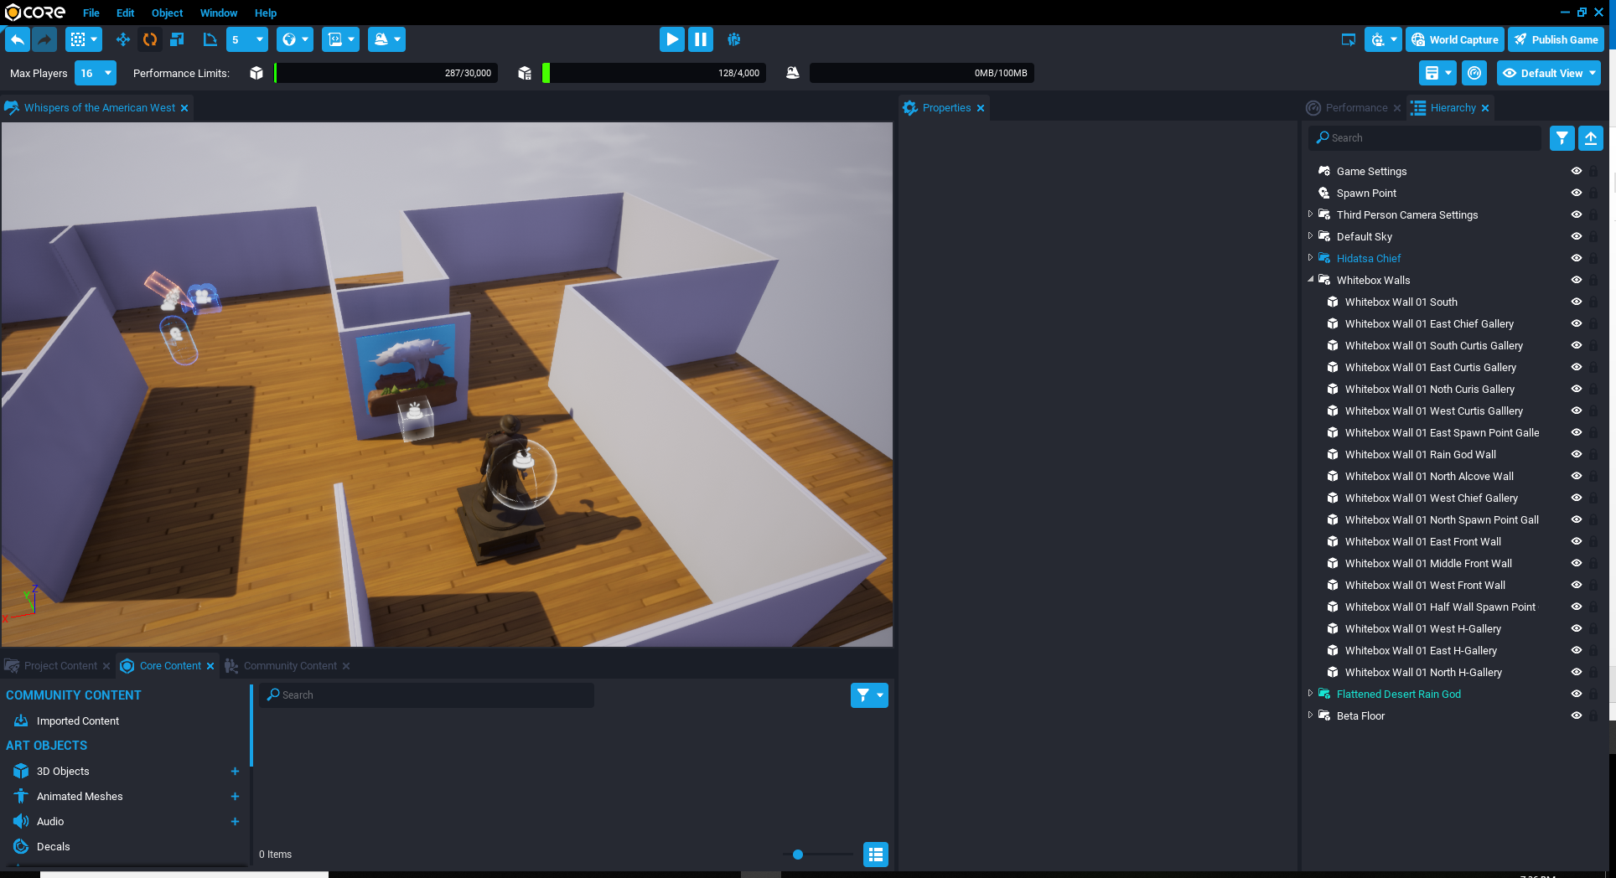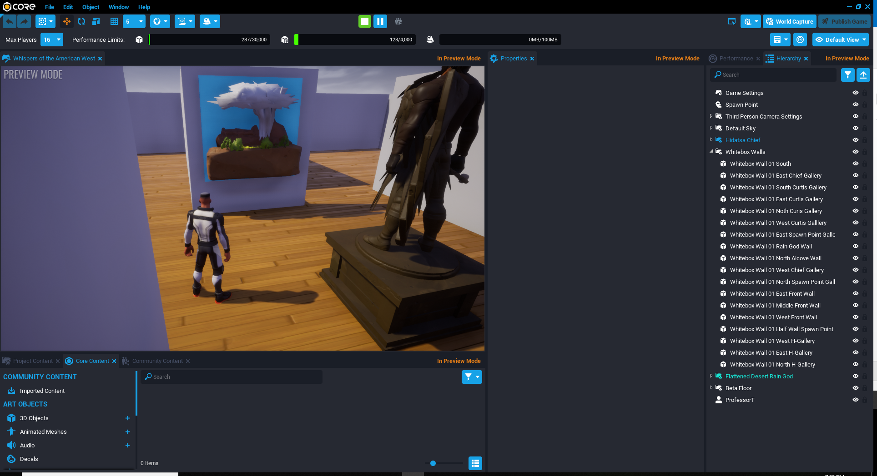When player approaches the painting in the hub level: wind rolls in, lightning starts, and thunder sounds. After a 3 second delay on lightning the name of Piece pops in. After a 3 second, delay the name of artist rolls in and thunder sounds again. Designed by Melissa Bridges (IAP 220: Introduction to Game Studies, Fall 2018, Level Design Document date: 09-27-2018)

## RELATED DOCUMENTS

|  |  |
| --- | --- |
| Name of Document | Name of Document |
| Concept Document | 00-Game Concept Document-WhispersOfTheAmericanWest-v2021.docx |
| Game Design Document | 01-Game_Design_Document-WhispersOfTheAmericanWest-v2021.docx |
| World Diagram – North Wing | 02-World Diagram-NorthWing.docx |

## OVERVIEW OF LEVEL DESIGN (DESERT RAIN GOD) (In Progress)

Spring 2021 notes on the design of the gameplay: Magic in the landscape (appearing mountain experience near Diné College, Devine); Hidden pathways that are revealed via exploration. Certain landscape features offer unique perspective that specifically reveal these pathways. (Griffin)

|  |  |  |
| --- | --- | --- |
| Level 18: 2010.255  [Desert Rain God](https://phxart.org/arts/desert-rain-god-dios-de-la-lluvia-en-el-desierto/)  (Phoenix Art Museum, 2010)  Design question: how to communicate unbalance and balance without being obvious? | **Goal:** Restoring balance  Rules: The sun will be released for movement via a mechanical device that is activated by knowledge acquisition.  Mechanics: Shadow Illusion by moving Sun using a mechanical device revealed after knowledge has been acquired.  Plot Point: a renewed discussion about the issues of uranium mining, pollution, and reversing the damage on the land of the Diné | **Challenge:** Acquisition of knowledge  Strategy: gain a piece of knowledge through stories and songs, including all the good and bad of life (Hozho)  Tactics: knowledge gained is about the about the provision in the treaty, uranium mining, pollution, and reversing the damage  Skills: Bloom’s Taxonomy  Applying: Judging, Experimenting  Analyzing: Correlating, Mind-Mapping  Evaluating: Assessing, Measuring, Predicting |

*.*

## LEVEL DESIGN DIAGRAM

The following landmarks demarcate the traditional lands of the Diné. (Denetdale, 2018) (Bureau of Reclamation, 2018) (US EPA, 2020)

**Four defining mountains**

* Blanca Peak (Sis Naajini); Mount Taylor (Tsoodzil); San Francisco Peaks (Dook’oosliid); Mount Hesperus (Dibe Nitsaa)

**Central Mountains**

* Gobernador Knob (Ch’ool’i’i), Huerfano Mountain (Dzil Na’oodilii)

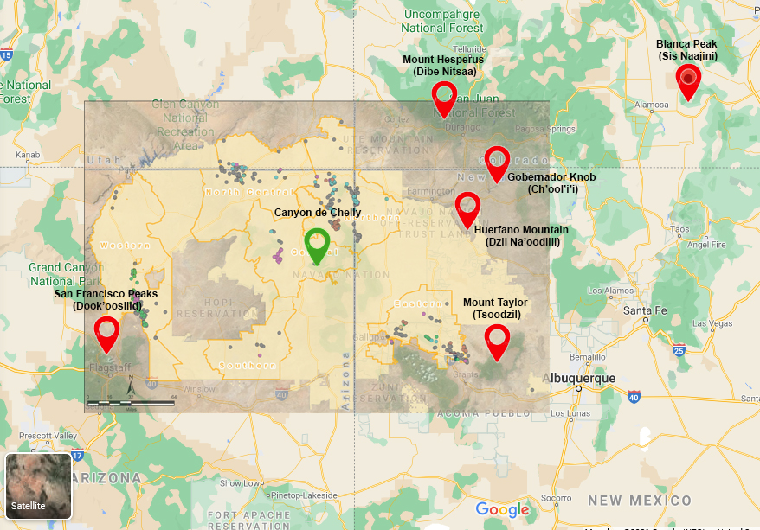

Abandoned Uranium Mines

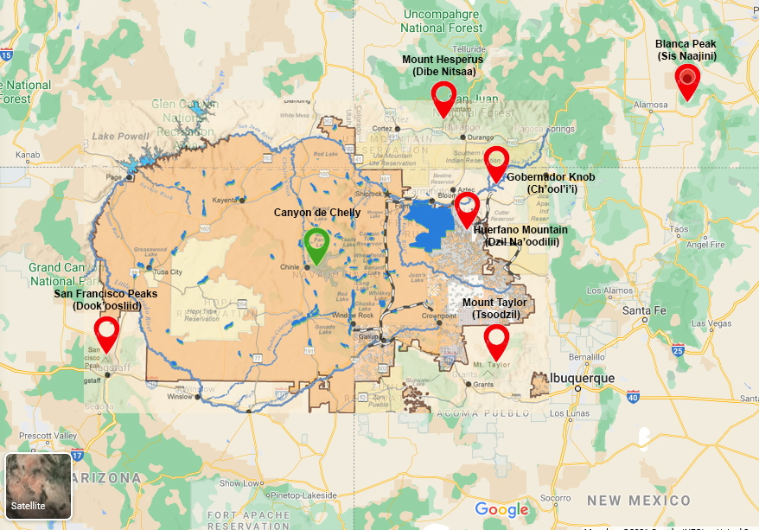

Water Futures, Blue is currently irrigated land

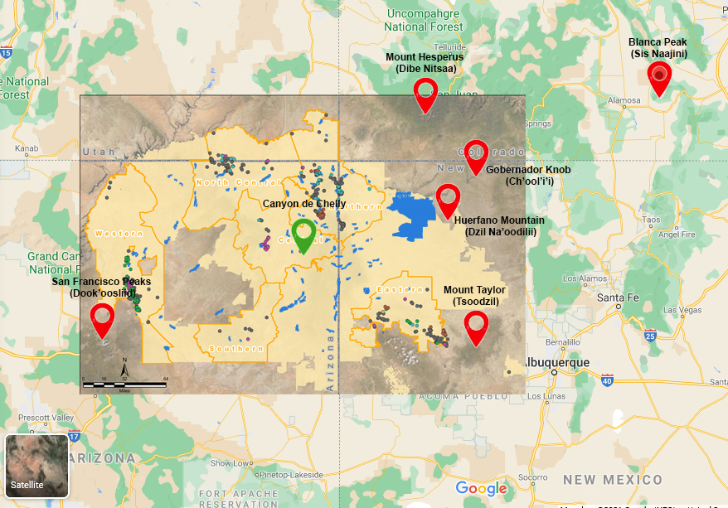

AUM + Water Future. Blue is currently irrigated land

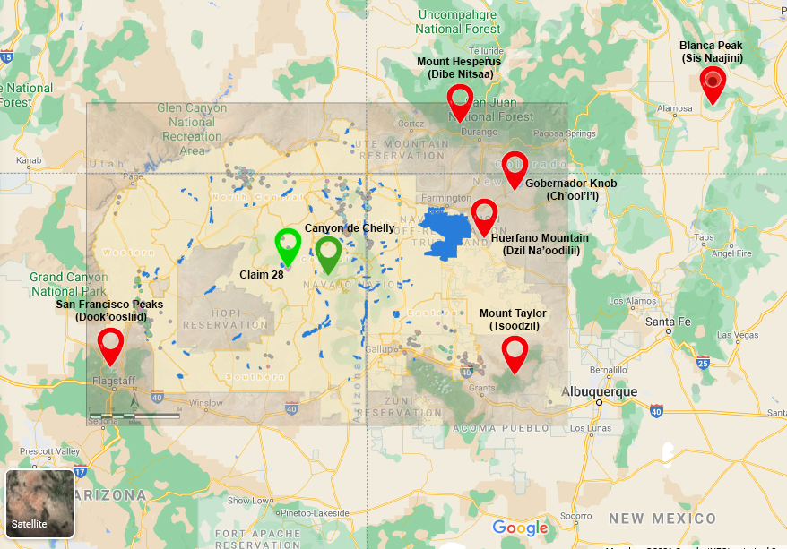

We will be concentrating on Claim 28 (79), which is located 37.8 miles west of Canyon de Chelly via Route 29.

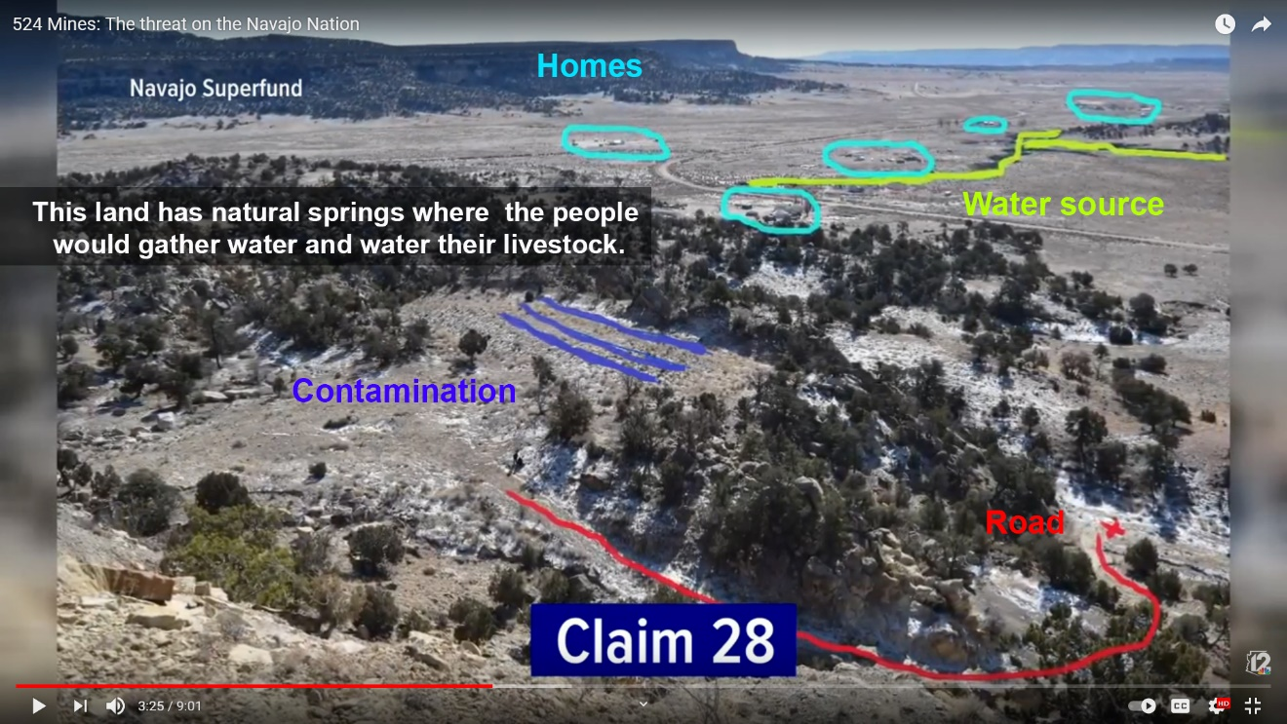

(12 News Arizona, 2020, p. timestamp 208s) <https://youtu.be/_cvt34m7tTk?t=208>

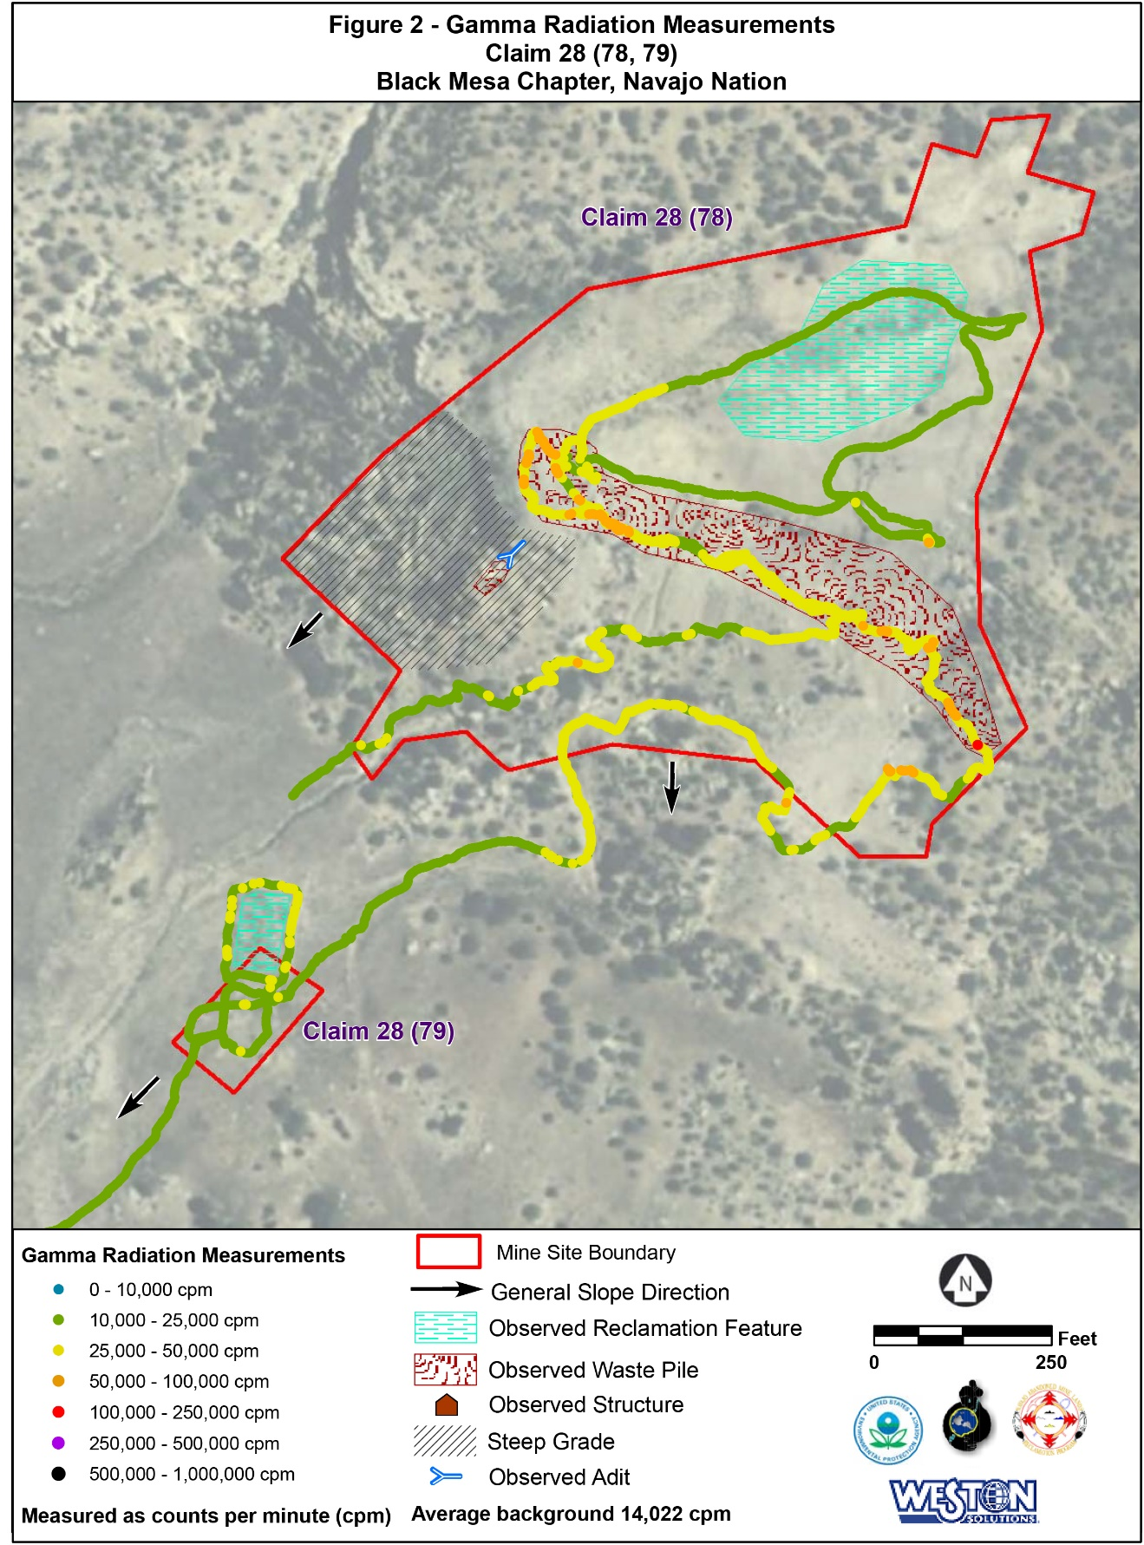

(US EPA, 2011, p. 15)

## PUZZLE AND MISSION DESIGN LIST (IN PROGRESS)

|  |  |  |
| --- | --- | --- |
| Name of Mission | Plot point | Name of Mission Design Document |
| Chapter 1: The Desert | In which the players begin an expedition to pick up the pieces | v1-0-Puzzle-Design-Document-Chapter-01-The-Desert.docx  (regular daylight)  Find mining equipment that has broken pieces. Dismantle the equipment. Pick up the pieces  Bring to abandoned mine. |
| Chapter 2: Before the Sun Rises | In which the players attempt to put the pieces together in darkness. | v1-0-Puzzle-Design-Document-Chapter-02-Before-The-Sun-Rises.docx  Player in abandoned mine with pieces. Attempt to put together in darkness. Several attempts made. Radioactive environment with radioactive water. It is not possible. |
| Chapter 3: Darkness | In which the players admit they do not know what they do not know | v1-0-Puzzle-Design-Document-Chapter-03-Darkness.docx  male rain (heavy rain floods etc) and female rain (light rain that nurtures).  Enter otherworld with storm from painting and collect raindrops for the god – only to discover the god is you. ??? how to use darkness? The player will be in a mine at this point. |
| Chapter 4: The Holy People | In which the players learn that goodness and balance are conferred by the Holy People. | v1-0-Puzzle-Design-Document-Chapter-04-The-Holy-People.docx  Maybe use “Little Rain God” character (must change – too much like Little Black Sambo and able-ist; maybe make him self-aware of the history of such characters? How to use the ‘chibi’ image?) |
| Chapter 5: The Lit Path | In which the players find the path before them has light. | v1-0-Puzzle-Design-Document-Chapter-05-The-Lit-Path.docx  Spatial Proximity (Farella page 24-25) – of supernatural and natural  Simultaneous Timeline |
| Chapter 6: Choice | In which the players choose to create a new future to make their grandchildren proud. | v1-0-Puzzle-Design-Document-Chapter-06-Choice.docx  moving the sun |

# ACCESSIBILITY & USE

*According to game accessibility guidelines, this level of the game will be made accessible according to the goals for accessibility the general inclusion strategies here.* (Game Accessibility Guidelines, 2012)

## INCLUSION

(Game Accessibility Guidelines, 2012, p. /basic)

|  |  |  |
| --- | --- | --- |
| Ability | Level (Basic, Intermediate, Advanced) | Strategy for inclusion |
| *Fine Motor* | *Basic* | *We will ensure controls are transferable to an adjusted keyboard.* |
| *Large Motor* | *Basic* | *We will ensure controls are transferable to an adjusted keyboard.* |
| *Cognitive* | *Basic* | *We will ensure the use of an easily readable default font size. We will use clear language.* |
| *Vision* | *Basic* | *We will ensure the use of an easily readable default font size and sounds to accompany key junctures in the progression of the game.* |
| *Hearing* | *Basic* | *We will ensure the use of visual indicators to accompany key junctures in the progression of the game* |
| *Speech* | *Basic* | *We will ensure that speech input is not required.* |
| *General* | *Basic* | *Custom difficulty levels will be implemented to ensure the maximum range of abilities will be able to play the game.* |

## USER CHARACTERISTICS

|  |  |  |
| --- | --- | --- |
| How many? | Title | Description of Characteristics |
| ?? | Casual Museum Attendees  (Adults, Parents, Kids) | All of these players will need no learning curve. These players are able to download and install the game on their computer and follow instructions to play the game. |
| 20 | Museum Docents | Are trained in educating the public about the collection. They will need further training in using the game. It should be simple for them as well. |
| 3 | Museum Educators | They manage the docents and the educational materials. They train and guide the Docents and the School Art Educators. |
| ?? | School Art Educators | Similar to the Docents, they are trained in the collection and will need training in using the game. |
| 5 | Museum Administrators | They oversee the entire initiative. They will play the game in order to review and approve it. |
| 10 | ASU student developers | Level Design and development of their assigned level. Will be new to game development in general. This will be a quickstart approach for them. |
| 1-3 | ASU Professors | Overall game design, research humanities and cultural studies for design, liaison between ASU student developers and the Phoenix Art Museum educators, guide the students to create a usable experience. |
|  | Community Partners and Contractors | Assets for gameplay, consultation on the environmental, political, social, and cultural studies for design. |

## USER OBJECTIVES

|  |  |  |
| --- | --- | --- |
| Title | Description of Objectives | Workflow |
| Museum Educators | Initiate project, review requirements and approve, test the game for final approval, train docents, art educators. Liason between ASU Professor and the PAM Administration. | First, intermediary reviews, final approval. |
| ASU Professor | Write GDD and project template for Level Design Documents, guide ASU student developers. Final design of the game and levels, | Second, intermediary reviews and guidance. Final approval before PAM Educators approve. |
| ASU student developers | Write Level Design document for their assigned level. Use template provided by ASU Professor Devine, build an AR experience that will be a level in the game produced. | Third. Use GDD requirements to write Level Design Documents and develop a level for the game. Each student will have a credit line. They will be primarily concerned with the player use cases. |
| Museum Administrators | Will approve the game for release in the PAM. | Fourth |
| Museum Docents | Will use the game in their tours after release. | Fifth |
| School Art Educators | Will use the game in their lessons after release. | Sixth |
| Casual Museum Attendees (players) | Play the game for fun, discovery of hidden knowledge | Last |

## GAME REQUIREMENTS

*These are the requirements for the game that will become the traceability matrix and will help the team communicate who are working on the game. There will be a scoping meeting with the team to determine which requirements will be built and which will be in the next release or iteration of the project.*

|  |  |  |  |  |
| --- | --- | --- | --- | --- |
| Done  (Y/N) | # | Requirement Description | Originator of Req. | Scope (In/Out) |
|  | 1 | The game shall be fun. | Phx Art Museum | In |
|  | 2 | The game shall be multiplayer | Theresa Devine | In |
|  | 3 | The game shall communicate the premise *Art Collections are a joyful celebration of humanity* | Phx Art Museum | In |
|  | 5 | The game shall be and Edutainment Video Art Game and/or have educational experiences that joyfully educate the public as to the diverse voices and contributions that formed the collection of the Phoenix Art Museum. | Phx Art Museum | In |
|  | 6 | The game shall have a rating of E for Everyone | Phx Art Museum | In |
|  | 8 | The game shall be developed by the IAP 220: Introduction to Game Studies at ASU | Theresa Devine | In |
|  | 9 | The game shall be aesthetically beautiful | Phx Art Museum | In |
|  | 10 | The game shall enhance the collection at the Phoenix Art Museum | Phx Art Museum | In |
|  | 11 | The game shall have a high degree of usability | Phx Art Museum | In |
|  | 12 | The game shall amplify marginalized voices. | Dean Sandrin | In |
|  | 13 | The game shall benefit Black Lives Matter and community by being actively anti-racist | Dean Sandrin | In |
|  | 14 | The game shall advance the University’s charter of inclusivity. | Dean Sandrin | In |
|  | 15 | The game shall make time and space for healing from racism to occur. | Dean Sandrin | In |
|  | 16 | The game shall use the guidelines for researchers on the shutdownstem.com website | Theresa Devine | In |
|  | 17 | The game shall avoid cliché and stereotypes | Theresa Devine | In |
|  | 18 | The game shall be readily available to the public for free | Theresa Devine | In |
|  | 19 | The game shall provide professional opportunity to students and game developers | Theresa Devine | In |
|  | 20 | The game shall use shadow illusion as one of its main mechanics | Theresa Devine | In |
|  | 21 | The game shall invite storytellers to contribute their work to the game experience | Theresa Devine | In |
|  | 22 | The game shall be inclusive of all ability types | Theresa Devine | In |

## USE CASE DIAGRAM (TO DO)

## USE CASE NARRATIVE (TO DO)

*Copy and paste this section for each of the use cases.*

|  |  |
| --- | --- |
| ***Details of the use case actors*** | |
| *Use Case Name:* |  |
| *Primary Actors:* |  |
| *Secondary Actors:* |  |

*Purpose:*

This use case occurs when a player initiates the game

*Trigger:*

The player or system requires opening the software.

*Pre-conditions:*

Using PC or Mac platform

*Basic Course:*

The splash screen appears and the player chooses to play, quit, or look at options

*Post-Conditions*:

Player enters the state of the game.

*Possible Alternate Flows:*

Exit out

# STORY ARCHITECTURE (TO DO)

*Is your game a narrative game? What plot points or character development will happen in this level of the game?  Will your game have moral choices? If so what ethical theory are you using to develop the story and mechanics? If your game does not have a story then you can delete this whole section.*

## STORY STRUCTURE

## STORY TYPE

## STORY THROUGHLINES

## SCRIPT MANAGEMENT

*Add a list of the scripts here and make note of what part of the story and plot points are revealed in this level.*

# VISUAL ARCHITECTURE

## AESTHETICS (TO DO)

Note: it is possible that this will not be used – but we are trying to preserve some of the students’ original ideas toward the final design. It has yet to be discovered how this design could be used in the final design of the level.

*The level is set in McElwain’s painting, so we will be making use of her depth and composition. The foreground is an excellent stage for the player character to move around from side to side and up and down because of the actual subject of the painting. For visual indicators, because the moving elements are designed to match as closely to the painting as possible, there will be a slight glow to indicate to the player what can be interacted with, so as to make it easier to distinguish without losing the impact of the color. For color blind accessibility, The glow indicating objects that can be interacted with will be different in value and texture from the background to prevent any reliance on the color.*

*Note: we might use something other than glowing for visual indicators*

## COLOR THEORY (TO DO)

Note: it is possible that this will not be used – but we are trying to preserve some of the students’ original ideas toward the final design. It has yet to be discovered how this design could be used in the final design of the level.

In an effort to maintain the vision of McElwain, her palette will be honored in the design of elements the game team adds. Each color is selected to match those present in Desert Rain God to match the feeling of majesty with cool deep blues and purples set against the soft warm oranges, yellows, and tans of the desert background.

These colors will also serve to make the player character stand out against the background more, as the backdrop will begin as a de-saturated brown and beige colors that the little Rain God’s blue and purple tones will stand out against. As the contrast is lessened and the painting becomes more vibrant, it will serve to immerse the player more wholly in the world of the painting.

*Note:Josef Alber’s Interaction of Color will be implemented in some way.*

## TYPOGRAPHY (TO DO)

Note: it is possible that this will not be used – but we are trying to preserve some of the students’ original ideas toward the final design. It has yet to be discovered how this design could be used in the final design of the level.

*The font used for the option, raindrop meter, and instructions will be from the Perpetua family of fonts, or a comparable serif font of equal weight that is available for licensing and within the Coregames engine. Perpetua is usable on Microsoft products for personal computer use. This choice was made because this family of fonts is easily readable, particularly as a serifed font, and it isn’t intense enough to distract from the primary focus of the game- the color progression. The backsplash for the raindrops is included to allow for the player to easily locate and then read the raindrop meter, and menus will also be on a backsplash, as the colors of the entire game will shift so much that a simple color difference will not be reliable enough for contrasting text from background. As there are no large blocks of text, rag, widows, and orphans will not be an issue. Additionally, standard kerning will be effective.*

## VISUAL CHARACTER DESIGN (Little Rain God) (TO DO)

Note: it is possible that this character will not be used – but we are trying to preserve some of the students’ original ideas toward the final design. It has yet to be discovered how this character could be used in the final design of the level.

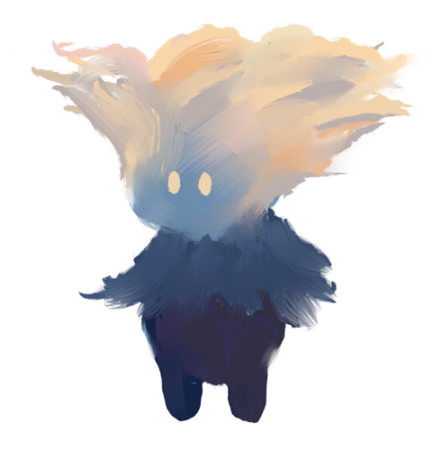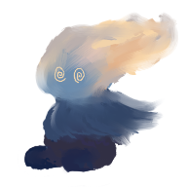

*The Little Rain God will need a walking, jumping, falling, getting up, stun, and hurt animation, with sounds to go with each. Concept Art by Ian McGonigle*

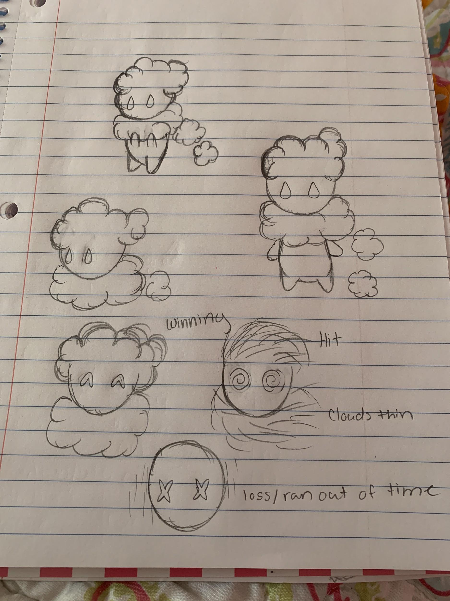

*Concept Art by Madesyn Mathews*

## BUTTON MAP

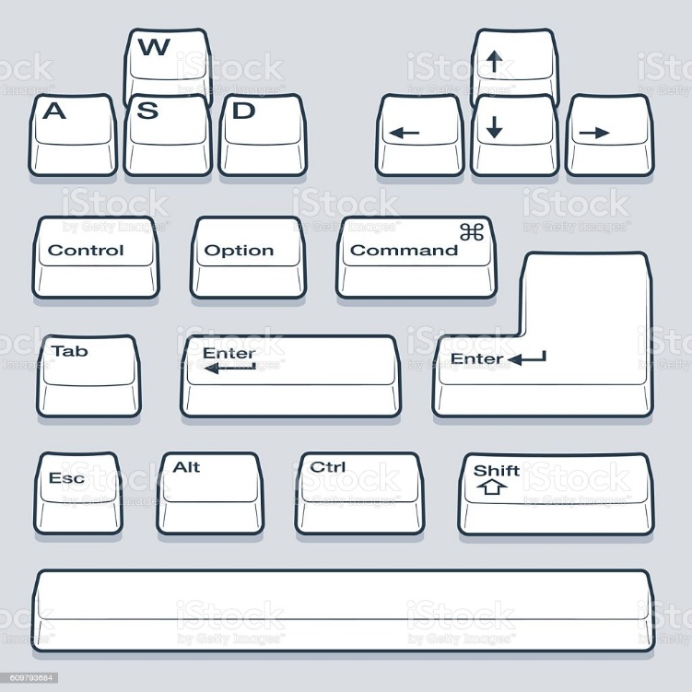

**

*Left arrow or A- move left*

*Right arrow or D - move right*

*Up arrow or W – move forward*

*Down arrow or S – move back*

*Space- Jump*

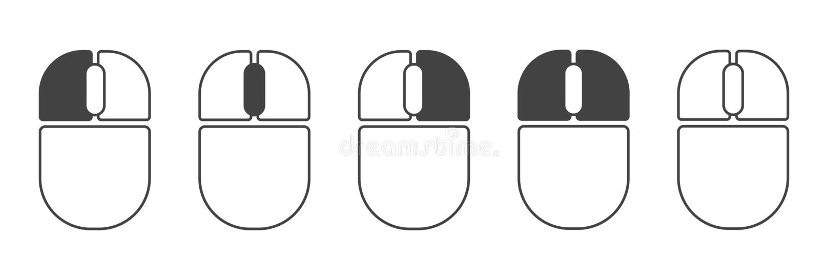

*Left Mouse button – Look or move camera*

## USER INTERFACE (TO DO)

Note: it is possible that this will not be used – but we are trying to preserve some of the students’ original ideas toward the final design. It has yet to be discovered how this design could be used in the final design of the level.

*Simple, Passive interface that is meant more as indicators for the player of how much time, lives, and raindrops they have at any given point during gameplay. Elements that can be interacted with will retain their color and shape throughout the game to keep the player aware of what items they should be looking for.*

## NAVIGATION HIERARCHY*.*

### Screen [1.0]: Player Start

* is centrally located in the North Wing, Western Art Gallery of the Phoenix Art Museum

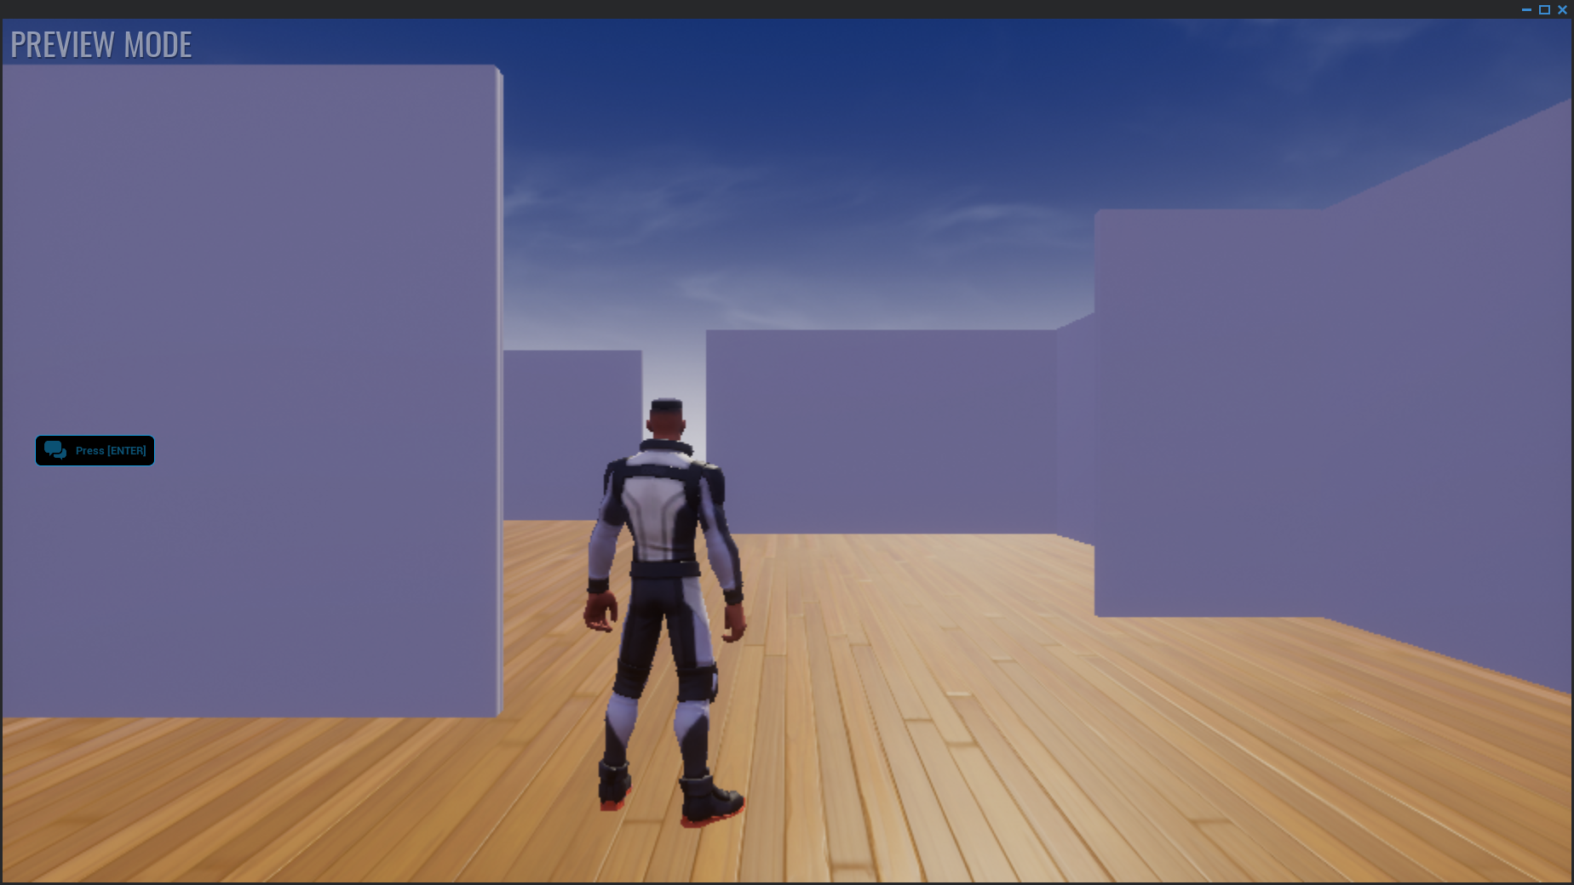

### Screen [1.1]: Player explores the North Wing

* Western Art Gallery of the Phoenix Art Museum to discover painting

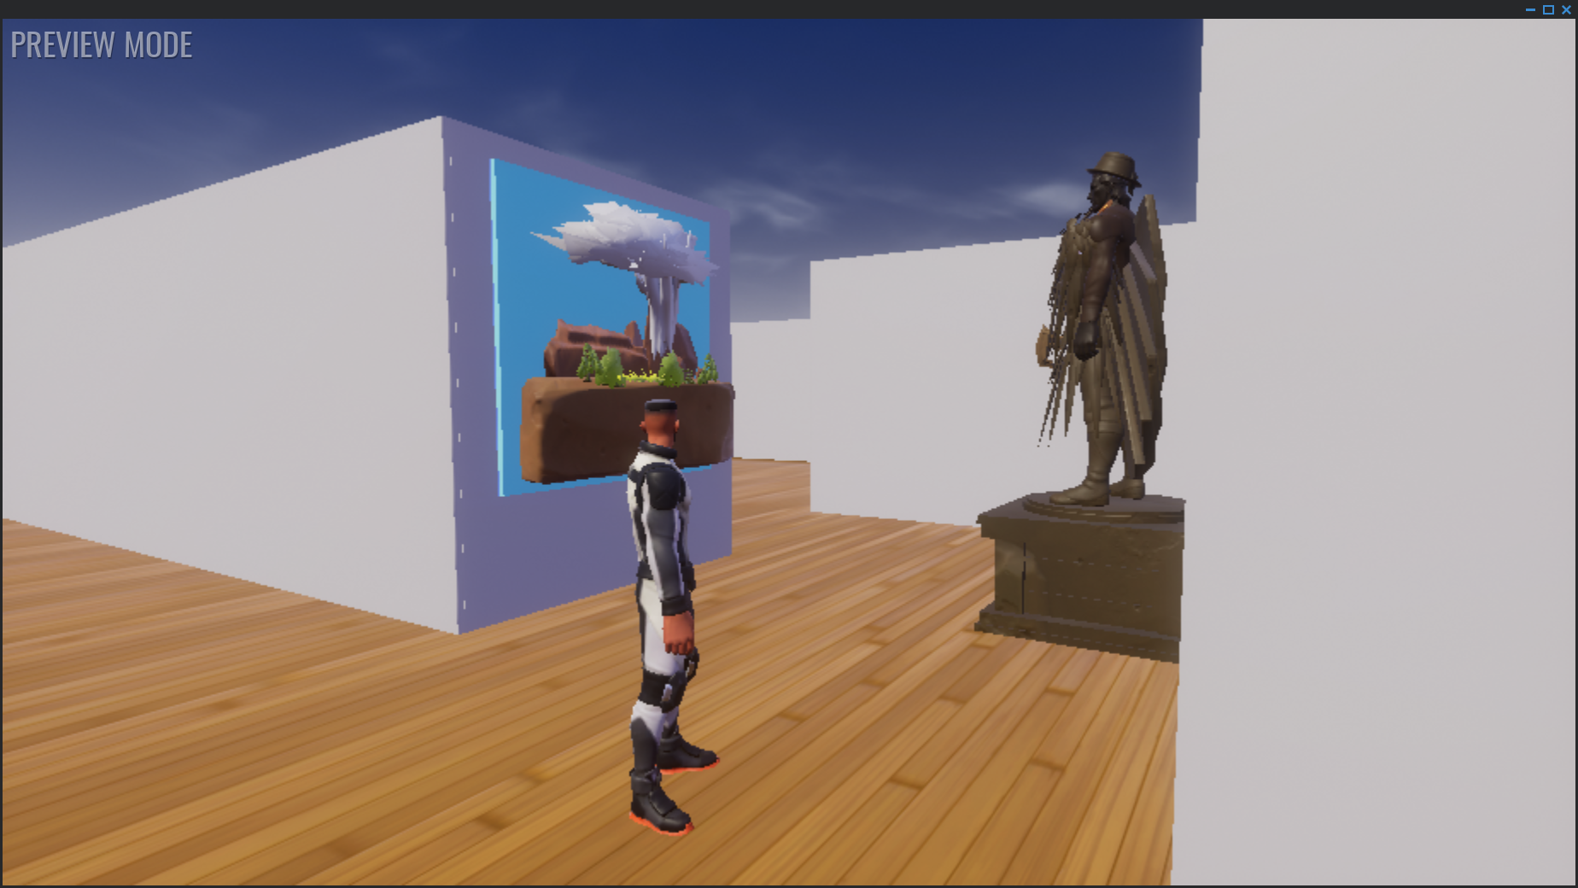

### Screen [1.2]: Player approaches painting

* and a trigger will automagically begin the thunder and lightning animation. A proximity trigger will transport the player into the Desert Rain God level.

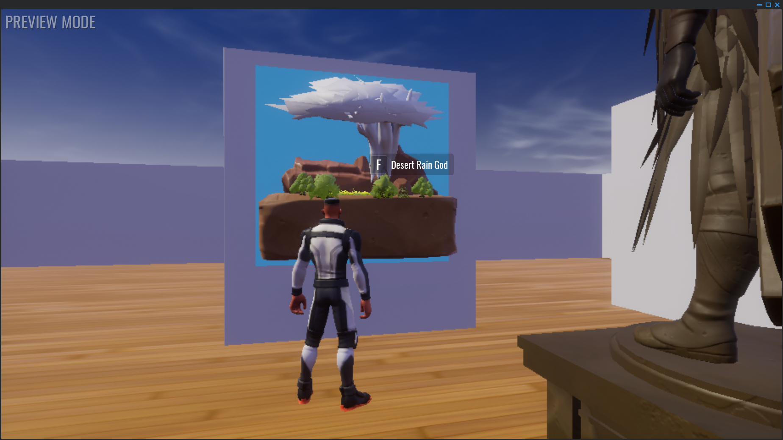

### Screen [2.0]: Player Start in the Desert Rain God Level

* is on a mesa. Player begins exploring the level.

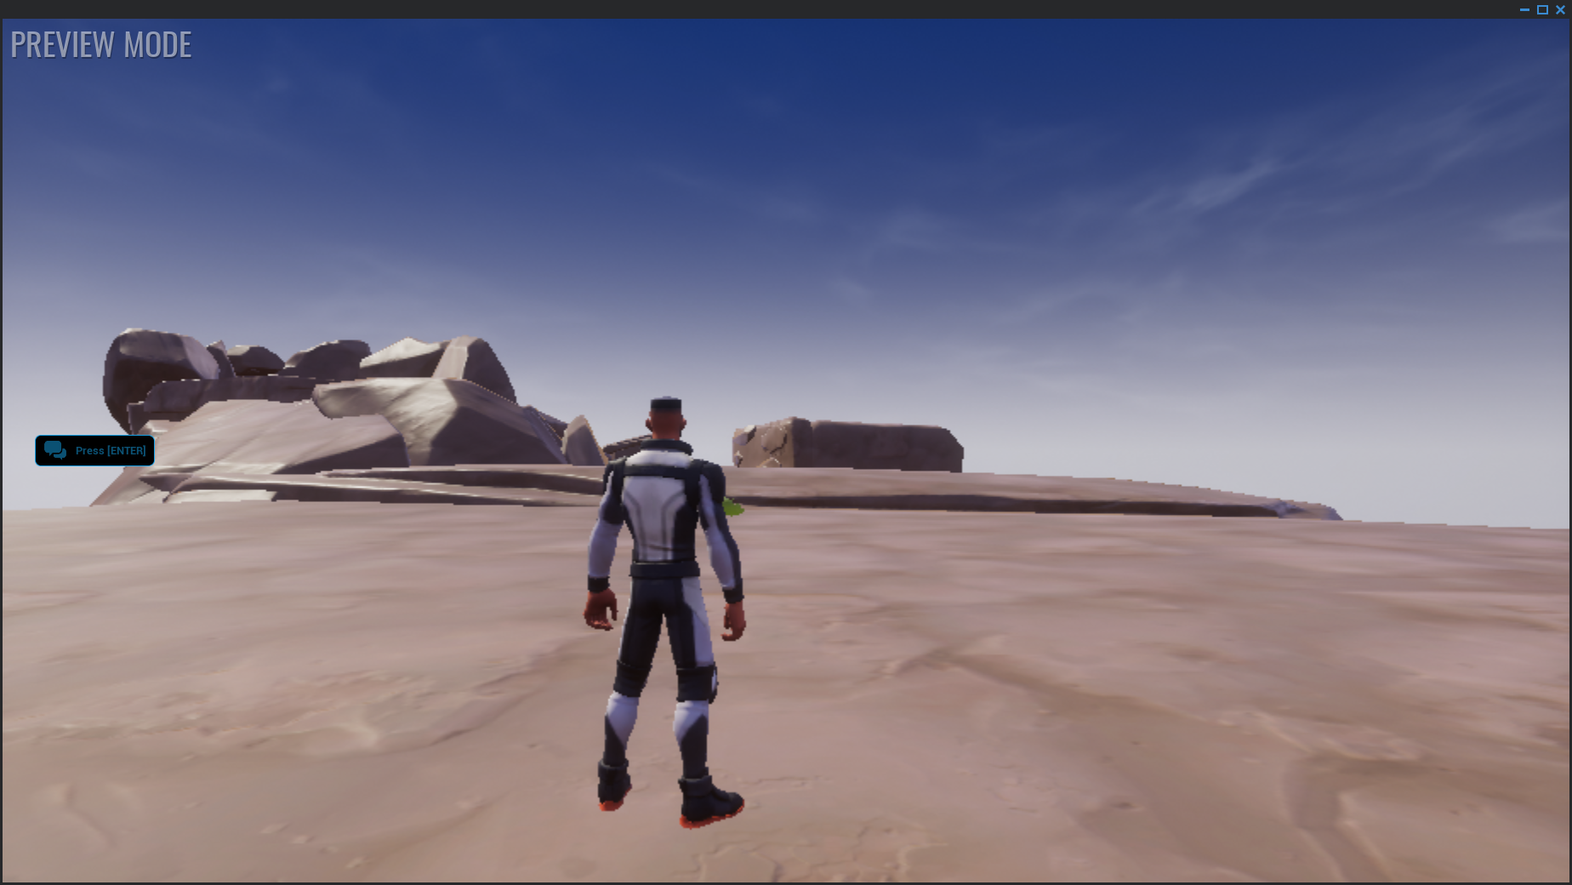

### Screen [2.1]: Player explores the level.

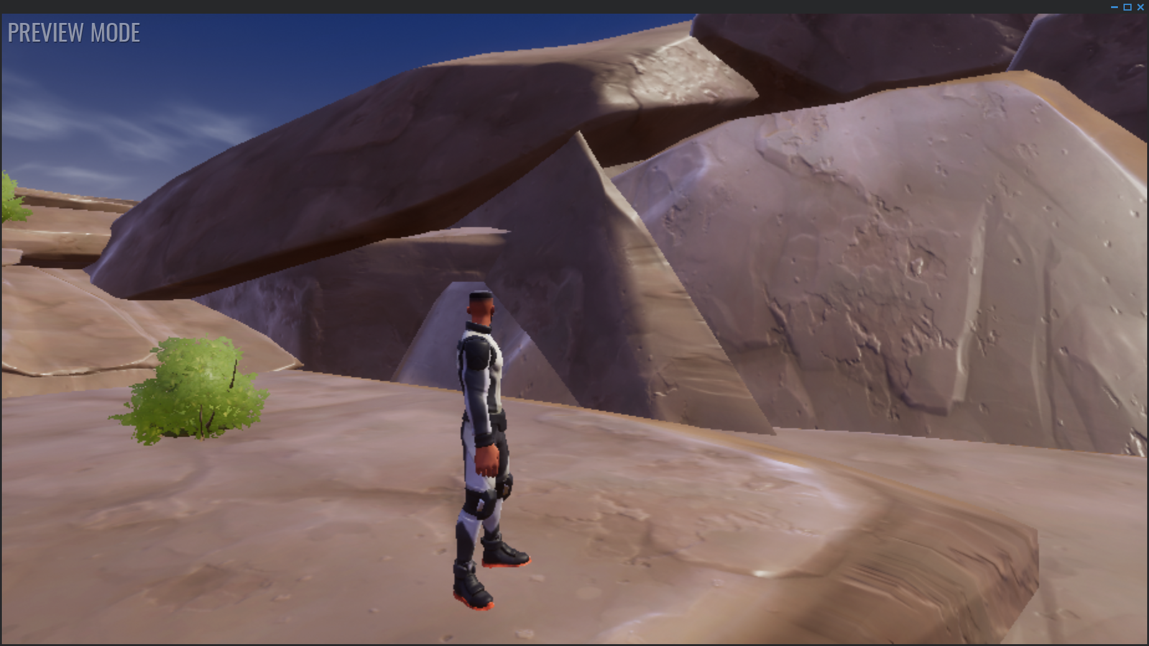

### Screen [2.2]: Player finds the abandoned mine.

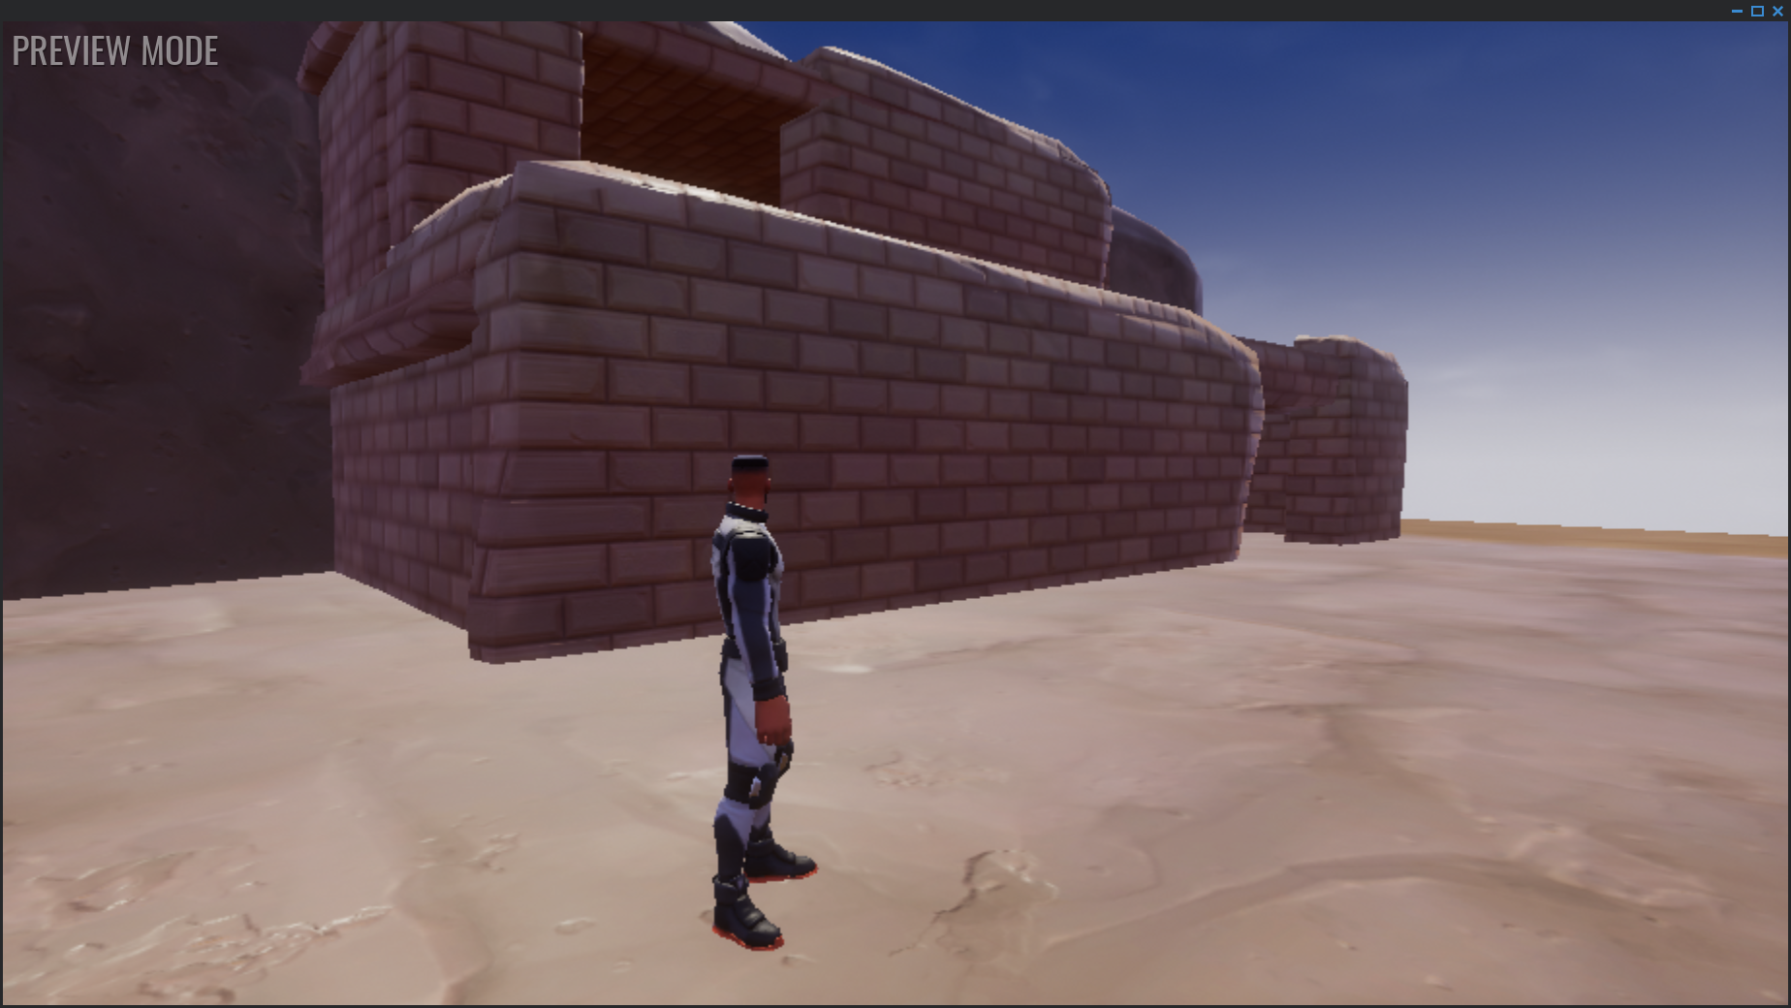

## ENVIRONMENT DESIGN

(US EPA, 2011, pp. 9-12)

### Actual Claim 28 Site Photos

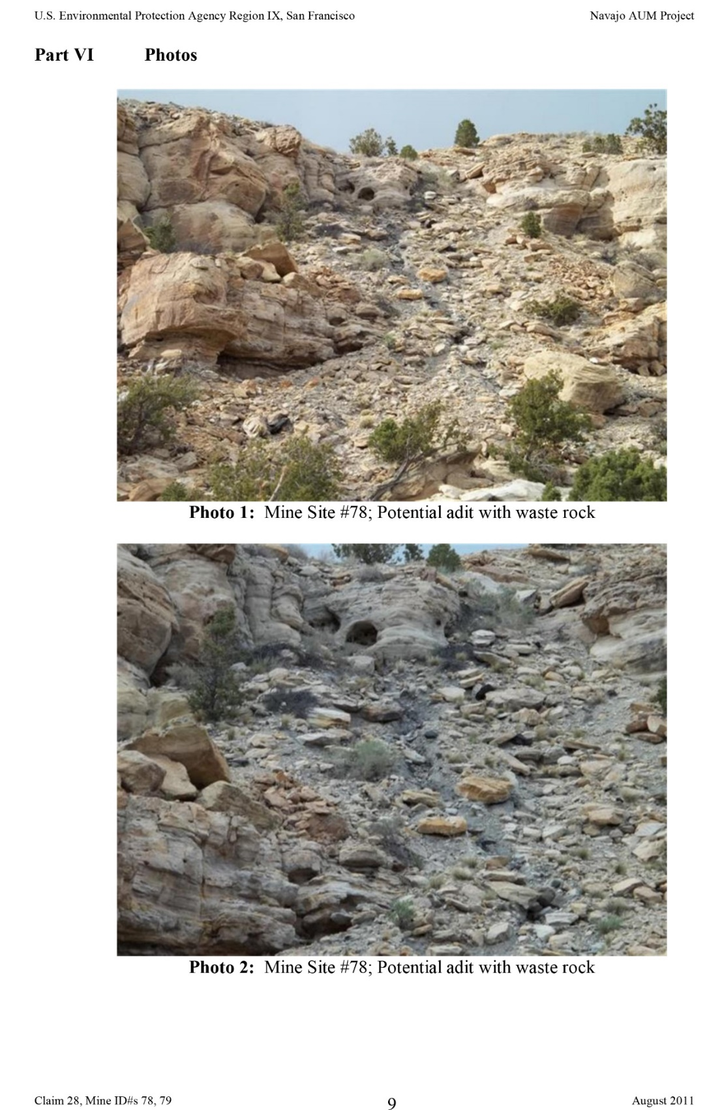

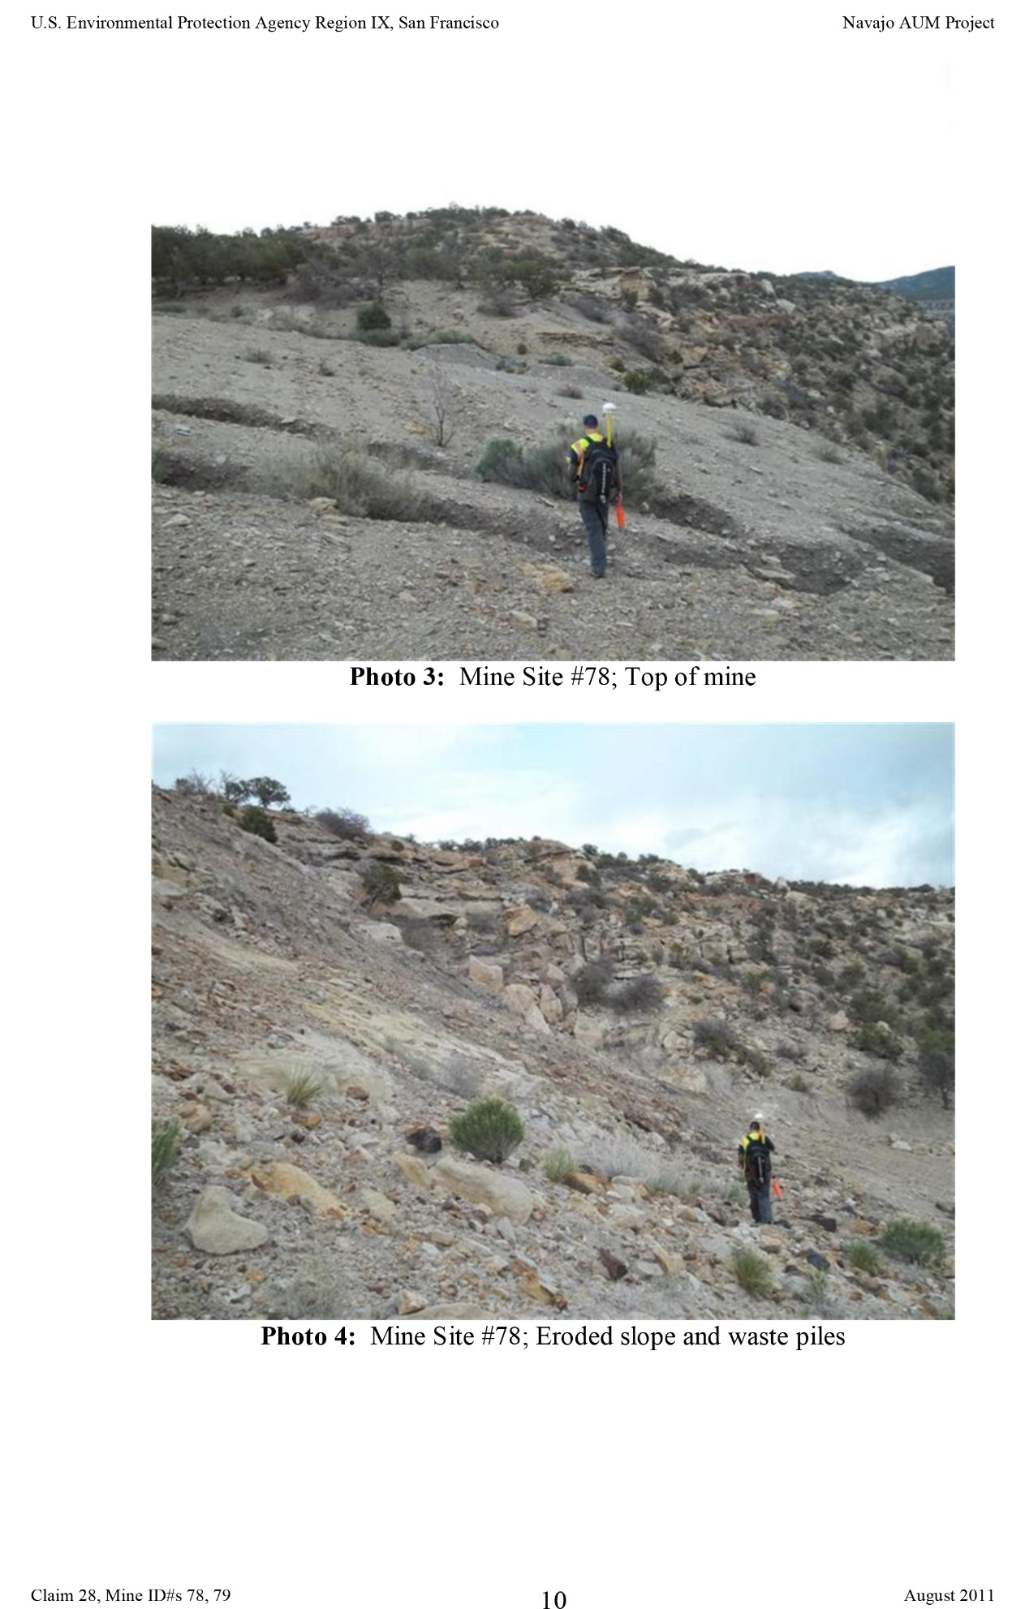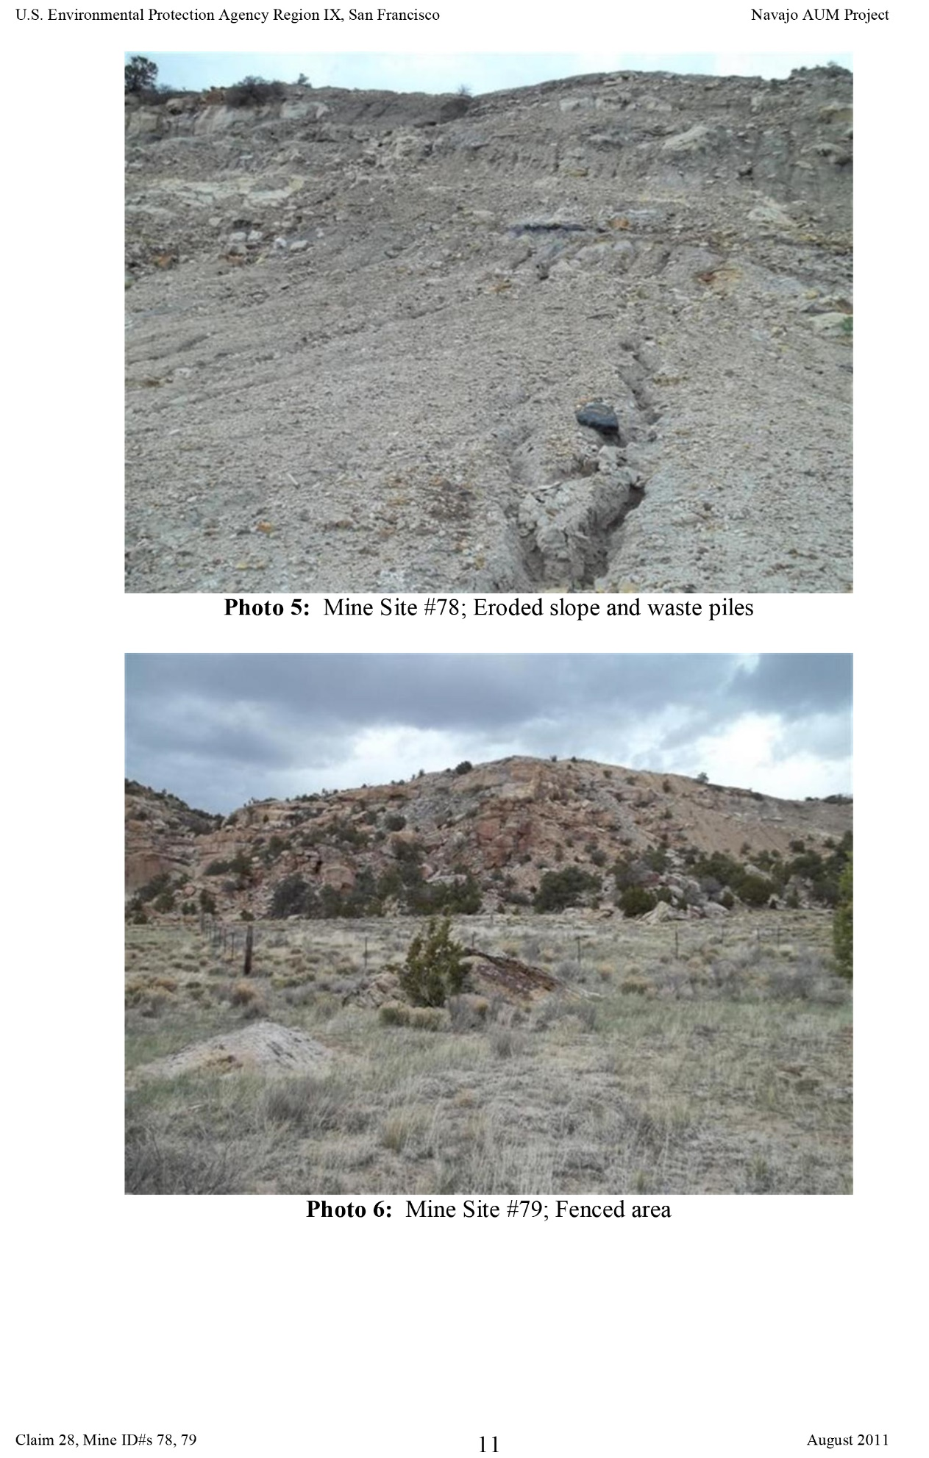

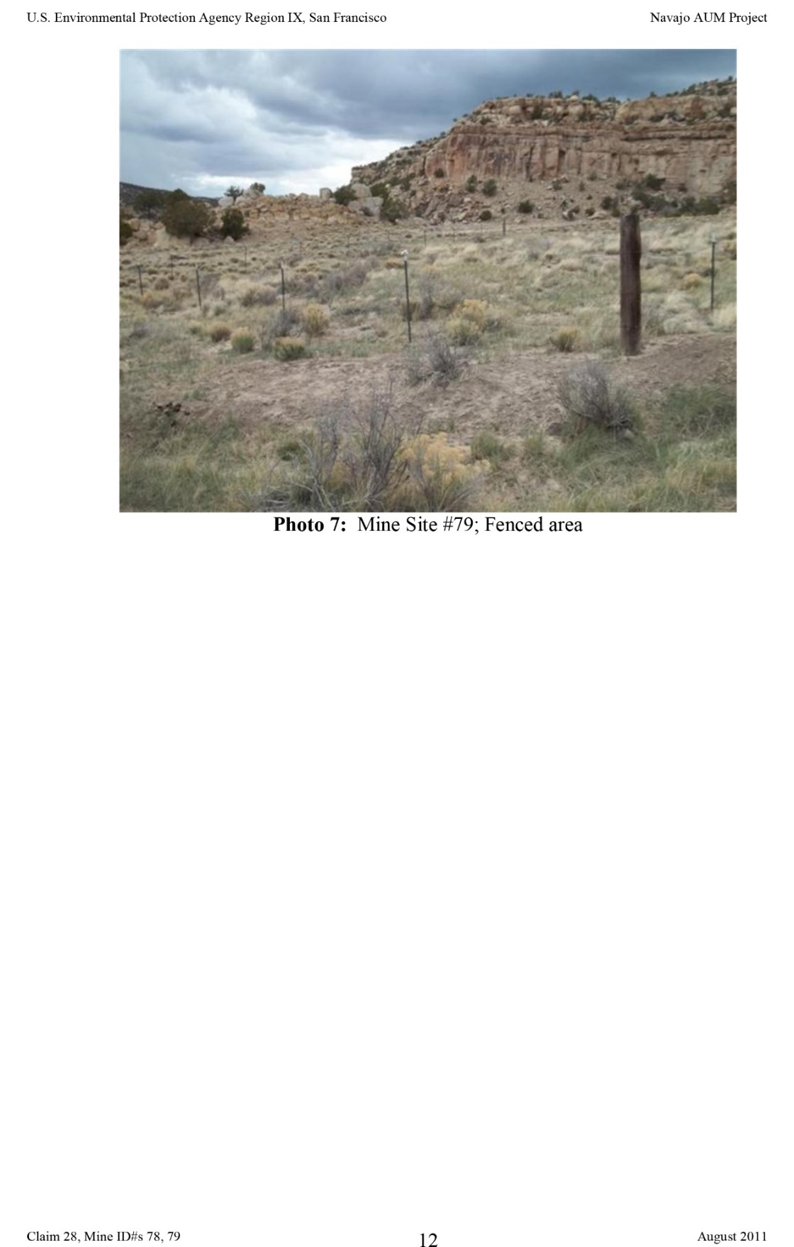(Page 12)

### General Mine Photos – Navajo Nation

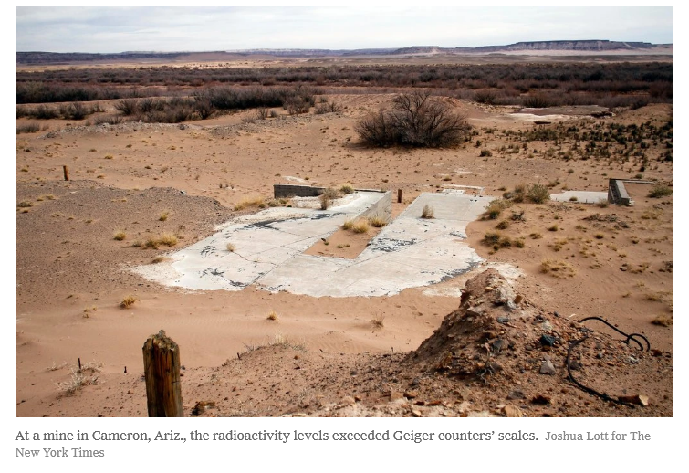

(Macmillan & Lott, 2012)

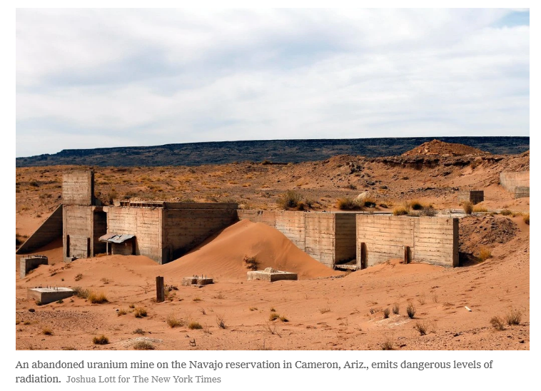

(Macmillan & Lott, 2012) (Environmental Health Perspectives, 2014)

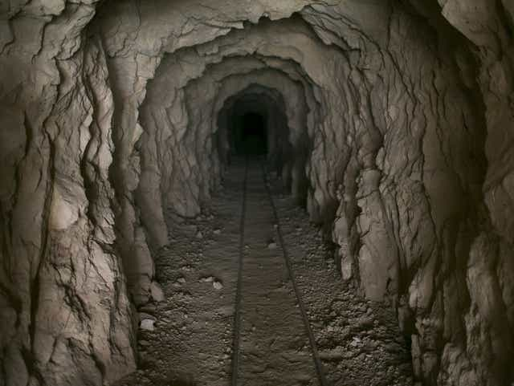

(Dungan, 2017)

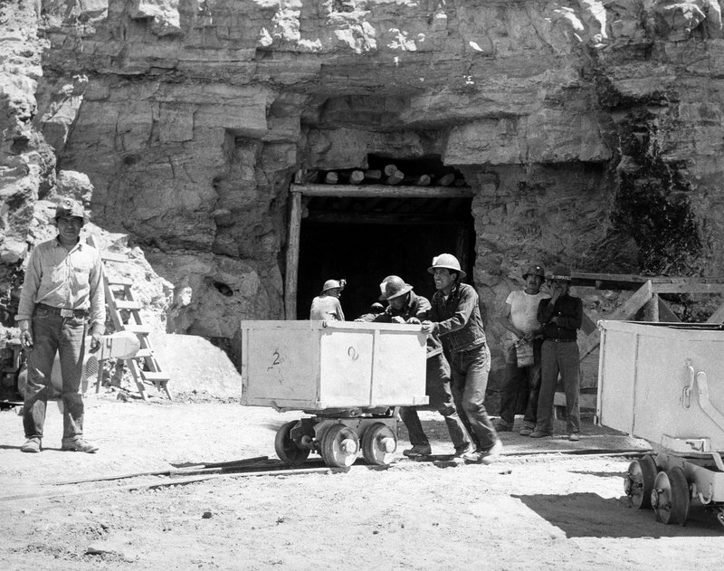

(Laurel Morales, AP Photo, 2016, 1953)

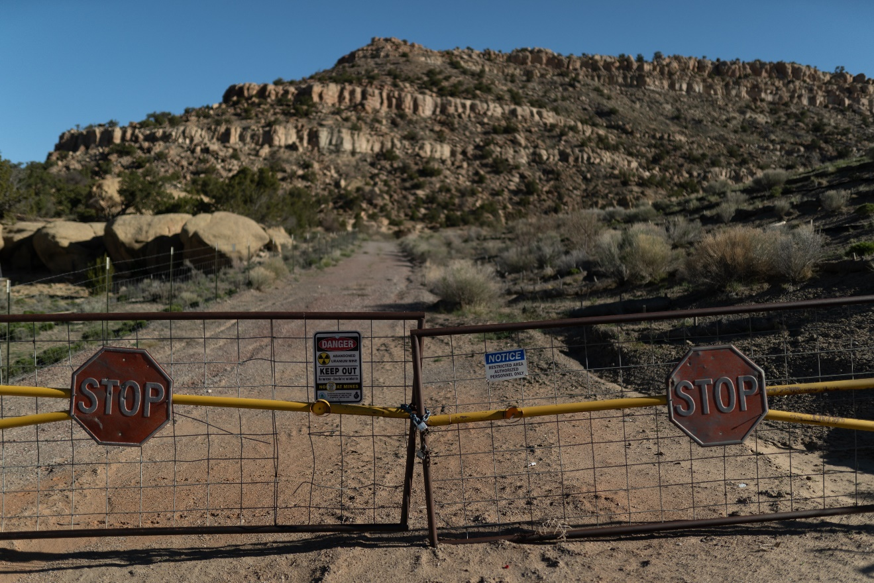

(Ford & John, 2020)

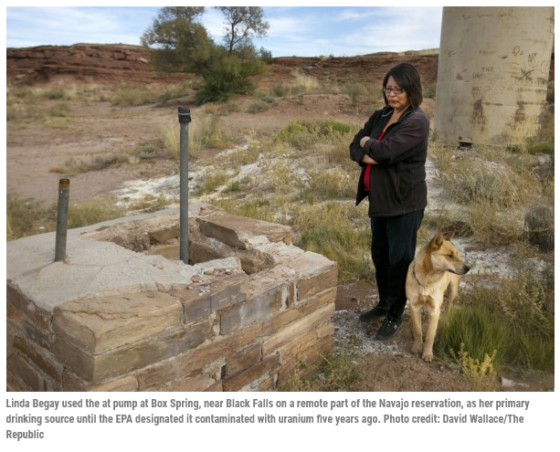

(Brandon Loomis; David Wallace, 2014)

### General Mine Photos – Utah

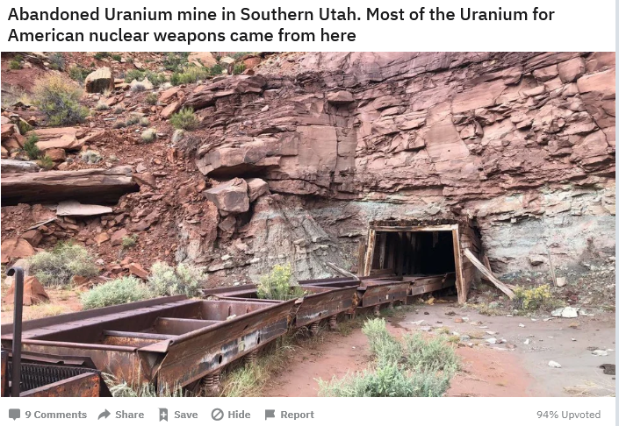

(Shanghai_Pete_1, 2020)

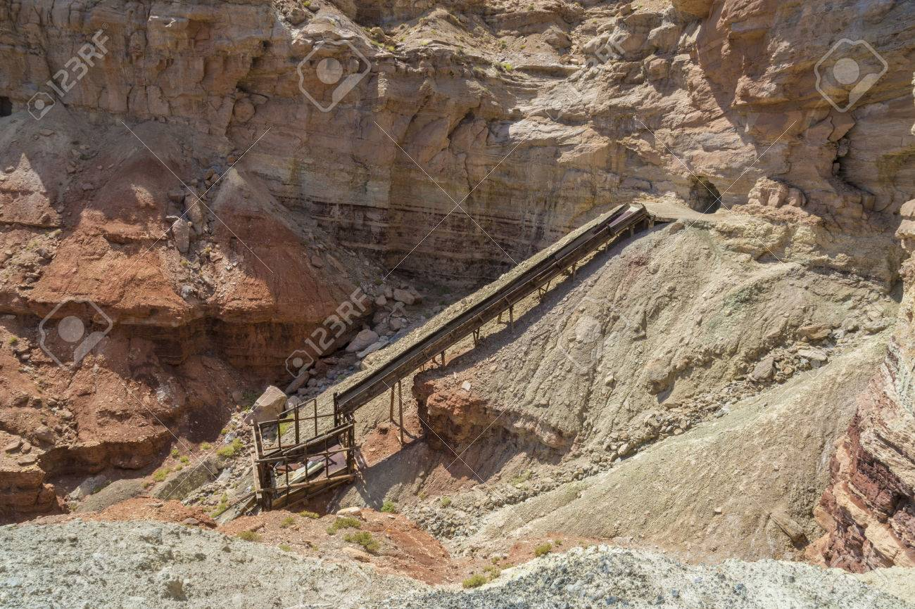

(Curtis, n.d.)

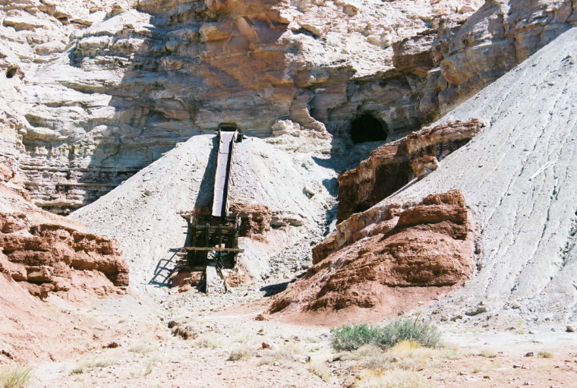

(Holtby & BLM)

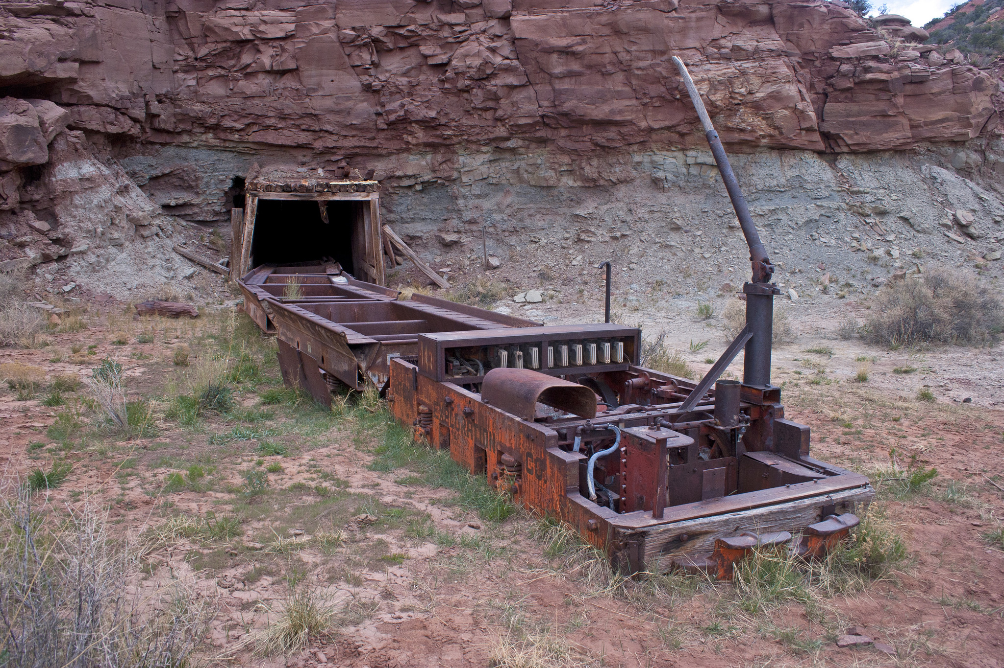

(ChewyUbleck, 2019, 2012)

### Mechanical Device Reference Image

# SONIC ARCHITECTURE

The sound will be composed and recorded by Yitazba Largo-Anderson and then recreated in the core game engine. This engine requires that all assets are kit-bashed. Yitazba will oversee the translation of the sound from her composition to the game sound and the students will do the technical set up of the sound and music.

## SOUND EFFECTS: STINGERS

* Yitazba Largo-Anderson to have final design and approval.
* Windy sounds, Thunderclap, Tumbleweed Impact, and Collecting Raindrops in a Bucket sound; Student Game Designers: Ian McGonigle, Rinaldo Del Gallo, Madesyn Mathews, Alvin Thai, Melissa Bridges

## SOUND EFFECTS: TAGS

* Yitazba Largo-Anderson to have final design and approval.
* Rain on plastic container, Bigger Windy Noises, Shiny sounds for sunshine; Student Game Designers: Ian McGonigle, Rinaldo Del Gallo, Madesyn Mathews, Alvin Thai

## MUSIC: INTRO (TO DO)

Yitazba Largo-Anderson to write and compose: <https://yitazba.square.site/>

<https://yitazba.bandcamp.com/releases>

<https://soundcloud.com/yitazba>

<https://distrokid.com/hyperfollow/yitazba/coyote-and-the-stars>

## MUSIC: LOOP (TO DO)

*When players sit idle too long, a peaceful soundtrack will play.*

Yitazba Largo-Anderson to write and compose: <https://yitazba.square.site/>

<https://yitazba.bandcamp.com/releases>

<https://soundcloud.com/yitazba>

<https://distrokid.com/hyperfollow/yitazba/coyote-and-the-stars>

## MUSIC: TRANSITION (TO DO)

Yitazba Largo-Anderson to write and compose: <https://yitazba.square.site/>

<https://yitazba.bandcamp.com/releases>

<https://soundcloud.com/yitazba>

<https://distrokid.com/hyperfollow/yitazba/coyote-and-the-stars>

# GAMEPLAY DESIGN AND SOFTWARE ARCHITECTURE

The main mechanic in the game will be a shadow illusion. Simplicity will be foregrounded with an influence from Kumi Yamashita (Yamashita, 2014)

Note of credit: we are using one of Yamashita’s images to create the mockup and show the idea.

|  |  |
| --- | --- |
| Sun position 1: Sun high in the sky | Position 2: Player moves sun to reveal figures. The position of the sun must be level with the rocks that hold the shadow information, approximately at the horizon, for the figures to appear. |
|  |  |

Actual symbolic imagery will need to be researched but this an example of what is imagined as to how this mechanic can work: Change the position of the sun to control the appearance and disappearance of the illusion. The image is there and must be discovered for the game to progress.

Additionally, we are influenced by this quote from the IAIA Museum of Contemporary Native Arts (MoCNA) and are interested in the key premise that “indigenous peoples of the Americas continue to live, survive and thrive in contemporary society.” The use of the figures appearing from the land shapes when the sun has been moved has the potential to simultaneously speak to the continuance of indigenous people to thrive in contemporary society, the lives lost due to the uranium mines, and the unfinished business of decontamination of the land.

**“**Of the many learning outcomes one may strive for in American Indian studies, this guide will focus on a select few. The knowledge that the indigenous peoples of the Americas continue to live, survive and thrive in contemporary society is the key premise this guide will seek to convey to learners. This contemporary presence is further enhanced by the assertion of a Native intelligence – a way of knowing that may encompass or even exceed the terms and patterns that we have come to associate with American Indian identities, cultures and histories to date.” (MOCNA Education Department, 2011, p. 3)

## LOGICAL VIEW (TO DO)

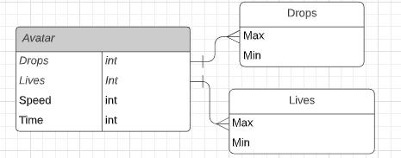

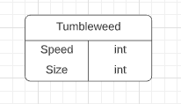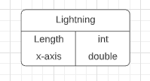

## DATA VIEW (TO DO)

Note: it is possible that this will not be used – but we are trying to preserve some of the students’ original ideas toward the final design. It has yet to be discovered how this design could be used in the final design of the level

*A relational database that is built in the CORE launcher will be used. This will keep track of numeric values each class uses. The avatar’s speed and health is affected by tumbleweeds and lightning that come into contact with its capsule collider. The number of tumbleweeds and lightning strikes is proportional to drops collected as a storm forms. When the game starts, the avatar has a time limit it can collect raindrops.*

## LOCALIZATION (TO DO)

Note: it is possible that this will not be used – but we are trying to preserve some of the students’ original ideas toward the final design. It has yet to be discovered how this design could be used in the final design of the level

*The game is available to anyone with virtual museum access worldwide. Adaptations with major languages will be included using translation dictionaries. When publishing the game, it will be usable on Mac, PC, and platform renderings available on CORE.*

## INSTRUMENTATION VIEW (TO DO)

Note: it is possible that this will not be used – but we are trying to preserve some of the students’ original ideas toward the final design. It has yet to be discovered how this design could be used in the final design of the level

*When creating the project, it will run at intervals to make sure it is working as intended with an IDE. Visual Studio can debug automatically and trace sections of code. Asserts, if-statements, and try-catch statements are usable for exception handling. Profiling can be done with trial and error of different input values. When adjusting colors, hybrid and visual lead can be consulted for desired output. Computer logging should reflect when game objects interact with another by experimenting the game and stimulating for the desired response.*

## SECURITY VIEW (TO DO)

Note: it is possible that this will not be used – but we are trying to preserve some of the students’ original ideas toward the final design. It has yet to be discovered how this design could be used in the final design of the level

*The game does not require security or memory. Each experience is randomized and the game is short enough that save files are not needed. Hexadecimal mac id filtering can limit the use of this software to museum visitors only.*

# BIBLIOGRAPHY

12 News Arizona. (2020, 03 06). *524 Mines: The threat on the Navajo Nation.* Retrieved 03 22, 2021, from YouTube: https://youtu.be/_cvt34m7tTk

Brandon Loomis; David Wallace. (2014, 08 15). Abandoned Uranium Mines Haunt Navajo Reservation. *Arizona Builder’s Exchange (AZ BEX)*. The Arizona Republic. Retrieved 03 22, 2021, from https://azbex.com/abandoned-uranium-mines-haunt-navajo-reservation/

Bureau of Reclamation. (2018). *Chapter 5.5 - Navajo Nation - Ch. 5.5 Navajo Current-Future Water Use 12-13-2018.pdf.* Retrieved from US Bureau of Reclamation: https://www.usbr.gov/lc/region/programs/crbstudy/tws/docs/Ch.%205.5%20Navajo%20Current-Future%20Water%20Use%2012-13-2018.pdf

ChewyUbleck, S. (2019, 2012). Abandoned Uranium Mine Adit. *Reddit, Flickr*. Utah, US. doi:https://www.reddit.com/r/TheForgottenDepths/comments/85wupb/abandoned_uranium_mine_adit/

Curtis, C. (n.d.). Stock Photo - Long abandoned Dirty Devil uranium mine in Emery County Utah. *123rf.com*. Retrieved 03 22, 2021, from https://www.123rf.com/photo_57339020_long-abandoned-dirty-devil-uranium-mine-in-emery-county-utah-in-the-san-rafael-swell-near-hondu-arch.html

Denetdale, J. N. (2018). aal Tsoos Saní (The Old Paper): The Navajo Treaty of 1868, Nation Building and Self-Determination. *American Indian Magazine, 19*(2). Retrieved 03 22, 2021, from https://www.americanindianmagazine.org/story/naal-tsoos-sani

Dooley, S. (2021). *Sunny Dooley - Home*. Retrieved 03 22, 2021, from Sunny Dooley: http://sunnydooley.weebly.com/

Dooley, S., Umayam, L., & Luis, A. (2019). *Ways of Knowing, A Navajo Nuclear History*. Retrieved 03 22, 2021, from Ways of Knowing: https://www.waysofknowing.us/

Dungan, R. (2017, 03 08). Is uranium mining near the Grand Canyon safe? The answer may be in the water. *The Republic*. Phoenix, AZ, US: azcentral.com. Retrieved 03 22, 2021, from https://www.azcentral.com/story/news/local/arizona-best-reads/2017/03/08/uranium-mining-near-grand-canyon-safe-answer-may-water/98816536/

Environmental Health Perspectives. (2014). *Once Upon A Mine: The Legacy of Uranium on the Navajo Nation.* National Institute of Envrionmental Health Services, Environmental Health Perspectives. Durham, NC, USA: National Institute of Health. doi:10.1289

Farella, J. R. (1990). *The Main Stalk: A Synthesis of Navajo Philosophy.* Tucson: University of Arizona Press. Retrieved from https://www.amazon.com/Main-Stalk-Synthesis-Navajo-Philosophy/dp/0816512108

Ford, W., & John, S. S. (2020, 01 18). A radioactive legacy haunts this Navajo village, which fears a fractured future. The Washington Post. Retrieved from https://www.washingtonpost.com/national/a-radioactive-legacy-haunts-this-navajo-village-which-fears-a-fractured-future/2020/01/18/84c6066e-37e0-11ea-9541-9107303481a4_story.html

Game Accessibility Guidelines. (2012). Retrieved from http://gameaccessibilityguidelines.com: http://gameaccessibilityguidelines.com

Harjo, S. S. (2014). *Nation to Nation: Treaties Between the United States and American Indian Nations.* Washington DC, New York: National Museum of the American Indian, Smithsonian Books.

Heard Museum. (2021). *Bluemoon Fundraiser*. Retrieved from https://heard.org/bluemoon/

Holtby, T., & BLM. (n.d.). DOE to report on abandoned uranium mines. *Moab Sun News*. Moab, Utah, US. Retrieved 03 22, 2021, from https://www.moabsunnews.com/news/article_6005cca8-b743-11e2-a81e-001a4bcf6878.html

Keynote Speakers Canada. (2019). *Nikki Sanchez*. Retrieved 03 22, 2021, from Keynote Speakers Canada: https://keynotespeakerscanada.ca/speaker/nikki-sanchez/

Laurel Morales, AP Photo. (2016, 1953, 04 10). For The Navajo Nation, Uranium Mining's Deadly Legacy Lingers. *NPR, KJZZ 91.5*(Weekend Edition). Phoenix, AZ, USA. Retrieved 03 22, 2021, from https://www.npr.org/sections/health-shots/2016/04/10/473547227/for-the-navajo-nation-uranium-minings-deadly-legacy-lingers

Macmillan, L., & Lott, J. (2012, 03 31). Uranium Mines Dot Navajo Land, Neglected and Still Perilous. New York, NY, US: New York Times. Retrieved 03 22, 2021, from https://www.nytimes.com/2012/04/01/us/uranium-mines-dot-navajo-land-neglected-and-still-perilous.html

MOCNA Education Department. (2011). *Manifestations: Curriculum Guide.* Retrieved 03 22, 2021, from Education > Institute of American Indian Arts (IAIA): https://iaia.edu/mocna/mocna-education/ (vision tab)

Phoenix Art Museum. (2010). *Desert Rain God (Dios de la lluvia en el desierto) - Phoenix Art Museum*. Retrieved 03 22, 2021, from PHXART.org: https://phxart.org/arts/desert-rain-god-dios-de-la-lluvia-en-el-desierto/

Phoenix Art Museum. (2018, 09). *Western Art Associates: Celebrating 50 Years - Phoenix Art Museum*. Retrieved from phxart.org: https://phxart.org/exhibition/western-art-associates-celebrating-50-years/

Sanchez, N. (2019). *Nikki Sanchez: Decolonization is for Everyone*. Retrieved 03 22, 2021, from TED, TEDxSFU: https://www.ted.com/talks/nikki_sanchez_decolonization_is_for_everyone

Shanghai_Pete_1. (2020). Abandoned Uranium mine in Southern Utah. *Reddit*. Utah, US. Retrieved from https://www.reddit.com/r/AbandonedPorn/comments/bptv98/abandoned_uranium_mine_in_southern_utah_most_of/

Umayam, L. (2013). *Bombshelltoe | Culture. Policy. Nukes.* Retrieved 03 22, 2021, from Bombshelltoe: https://bombshelltoe.com/

Unitah Basin Teaching American History. (2006). *Microsoft Word - Navajo Treaty of 1868.doc - doc33.pdf.* Retrieved 03 22, 2021, from http://www.uintahbasintah.org/usdocuments/doc33.pdf

Unknown. (2012, 07 16). Beauty Balance Hozho: Hozho: Dine Concept of Balance and Beauty. Retrieved 03 22, 2021, from https://bombshelltoe.com/

US EPA. (2011, 08). *Claim 28 AUM Site Screening Report - 78_79.* Retrieved 03 22, 2021, from EPA.gov: https://www.epa.gov/sites/production/files/2017-04/documents/78_79_Claim_28_AUM_Screening_Report.pdf

US EPA. (2014). *Abandoned Mines Cleanup | US EPA*. Retrieved 03 22, 2021, from US EPA: https://www.epa.gov/navajo-nation-uranium-cleanup/abandoned-mines-cleanup

US EPA. (2020, 11). *Fact Sheet: Abandoned Uranium Mine Settlements on the Navajo Nation.* Retrieved from EPA.gov: https://www.epa.gov/sites/production/files/2021-02/documents/navajo_nation_settlement_fact_sheet-2020-11-19.pdf

Yamashita, K. (2014). *Light & Shadow*. Retrieved 03 22, 2021, from Kumi Yamashita: http://kumiyamashita.com/light-shadow

Zolbrod, P. G. (1987). *Diné Bahane': The Navajo Creation Story.* Albuquerque: University of New Mexico Press. Retrieved from https://www.amazon.com/Din%C3%A9-Bahane-Navajo-Creation-Story/dp/0826310435/